Power BI Bootcamp – Creating a Report on London Crime Statistics

Glenn Pepper
Cloud Solutions Architect – Data and AI EMEA

28/10/2026
Version 3.0

Contents
Executive Summary 5
Download the Dataset 6
Crime Data 6
Population Data 7
Connect to Data Source 8
Connect to a folder containing multiple CSV files 8
Connect to an Excel File 10
Shaping Data 14
Rename Queries 14
Removing Columns: 15
Rename Columns 15
Change Data Types 16
Remove Nulls/Replace Values 18
Split Column 19
Trime Data 21
Merge Queries 21
Finishing Up 24
Relationships 25
Modeling Data 28
Create a Date Dimension Table 28
Create Monthly Bins 29
Data Categorization 31
Hierarchies 31
DAX CALCULATIONS 33
Measures 33
Report Theme 36
Create your First Report Page 38
Visualizations 42
Custom Visual download 42
Page 1 44
Page 2 49
Create Drill-Through Page 54
Create a Tooltip 60
Thoughts about Extending Your Model 63
Q & A Visualization (Power BI Service Only!) 64
Create a Workspace for your Report 66
Publishing Your Report to Power BI Server 68
References 69

Executive Summary
This document is for the bespoke Power BI Proof of Concept and Educational workshop. It has been compiled to allow complete novices and newcomers to Power BI to create a full working report with a sample Power BI dataset. The document will attempt to introduce all the required workflow, concepts and processes required to create and manage a fully working and aesthetically pleasing Power BI report.

Download the Dataset

Crime Data
The required data for this report is available in CSV format from the following location:
Data downloads | data.police.uk
I select the ‘Metropolitan Police’ and ‘City of London Police’ Datasets and I would recommend selecting at least 12 months of data to use as this will give a much richer and meaningful report.

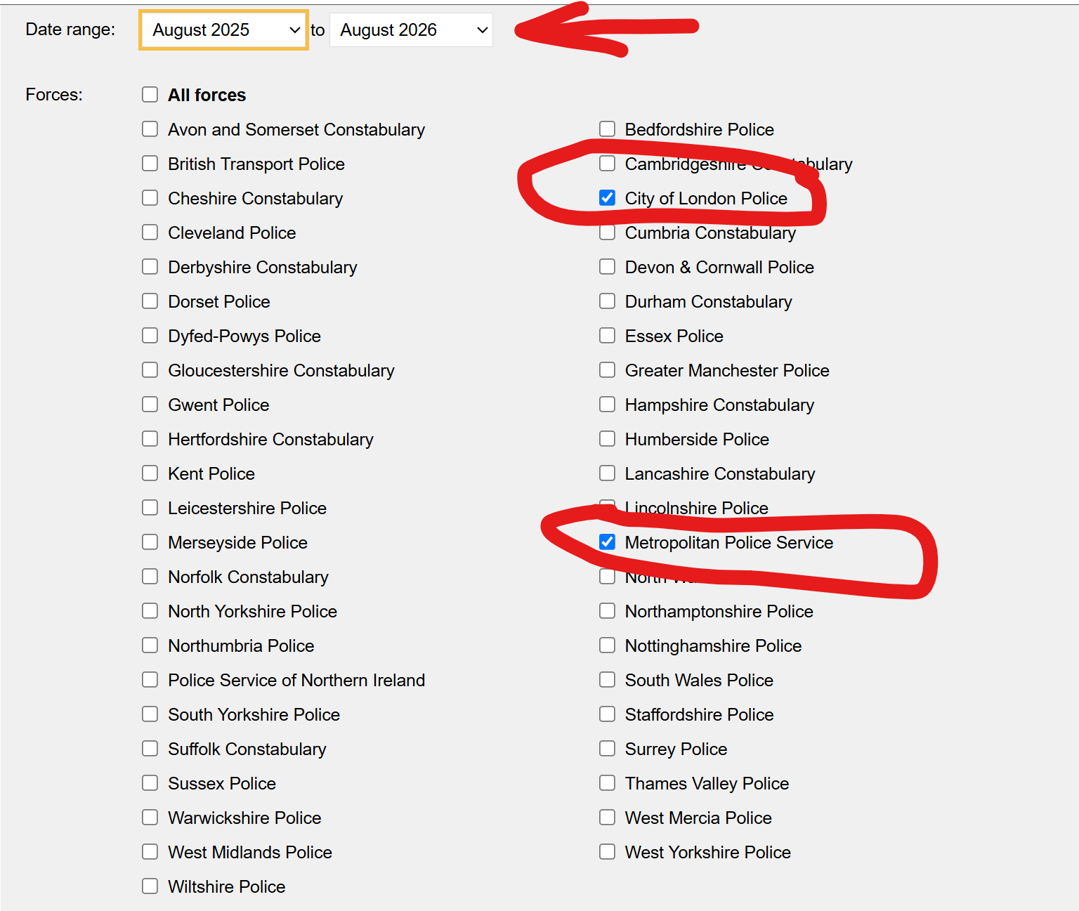
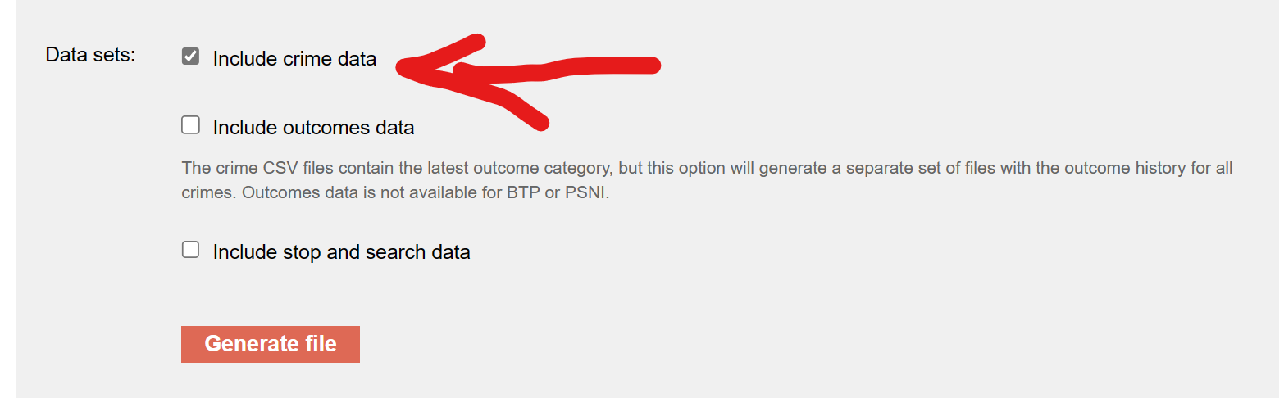

When you generate the file, it will be in zip format. Download it, extract the data to a sensible location you can reach with Power BI Desktop and keep the folder structure the same. The larger the amount of data, the longer it will take to generate, download and shape the data in Power BI.

Population Data
I have created my own Population Spreadsheet to simplify things as the key to this bootcamp is creating a report, not cleaning and shaping data.
I have embedded the population excel spreadsheet in this document that can be stored with in it’s own folder called ‘population’ with the crime data.

The data folder structure should look like this:
The crime data should be in ‘Extended Data’ and the above spreadsheet should be in ‘Population’.

Connect to Data Source

Connect to a folder containing multiple CSV files
- Open Power BI Desktop and click on the ‘Get Data’ button/icon.
- Next, click on File in the side-menu and then select ‘Folder’ and then click on ‘Connect’.
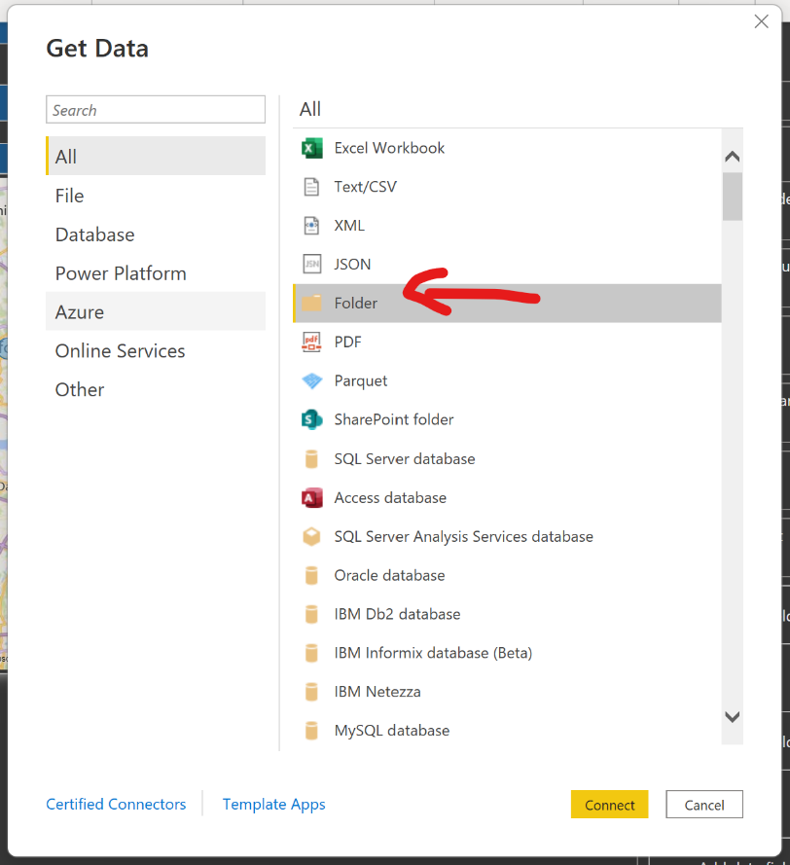
- Browse to the folder called ‘extended data’ which you should have received as part of this course. Ideally you would have placed this folder in a OneDrive location (to allow automatic refreshes of data once the report is published – more on that later).
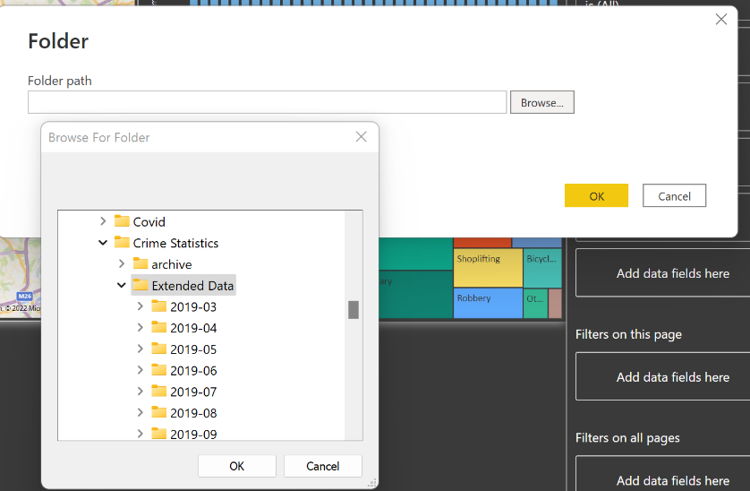

- Next, select ‘Combine and Transform’ and then in the 2nd window, select ‘Combine’ to combine all CSV files in the folder into one query/table and take you to the Power Query Editor.
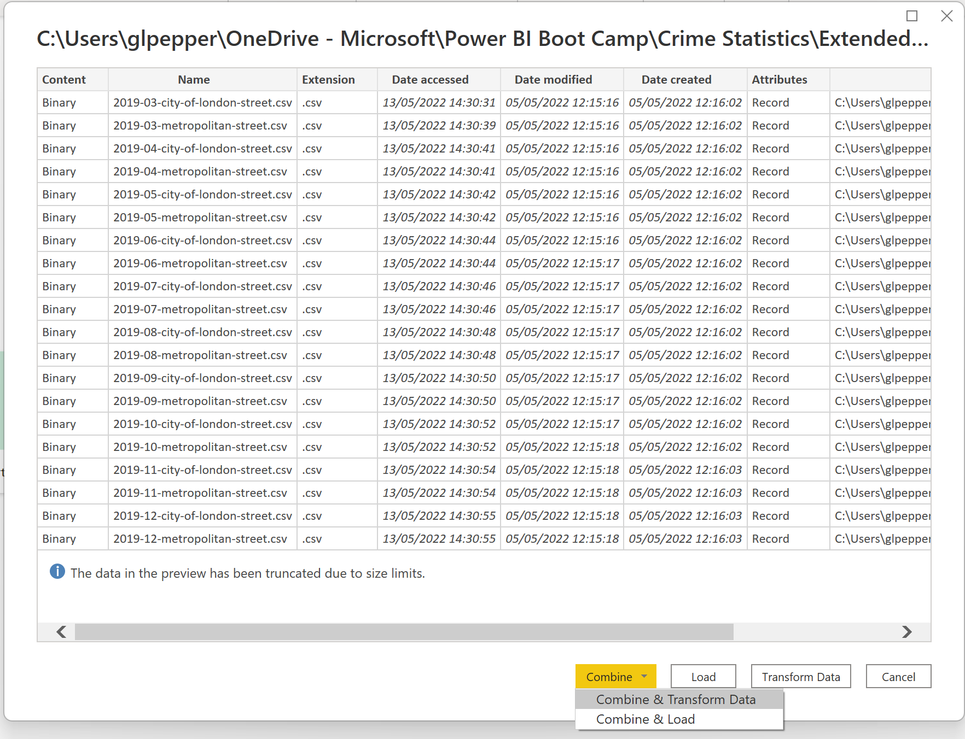
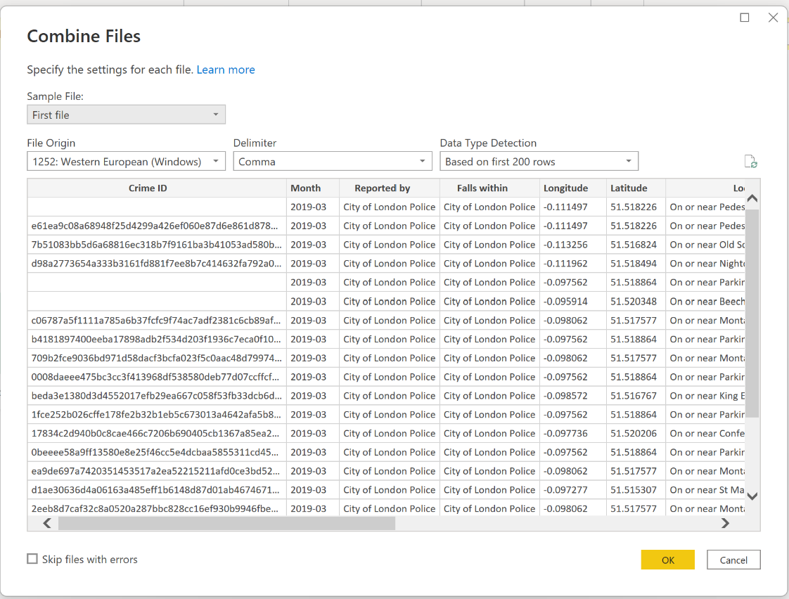

Your Screen should now look like this:
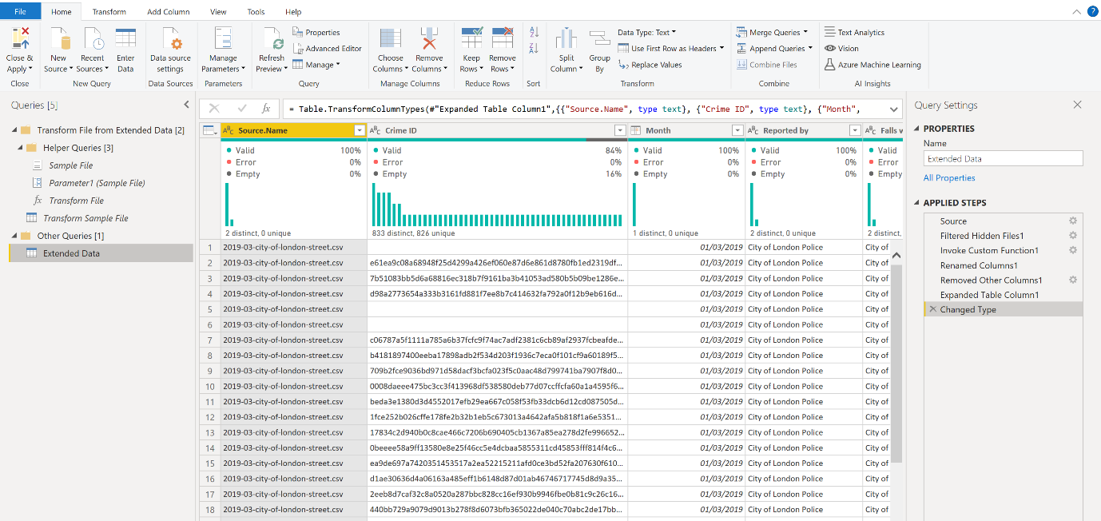

Connect to an Excel File

- In Power Query Editor, click on ‘New Source’ and select ‘Excel Workbook’.
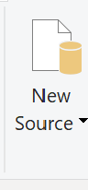
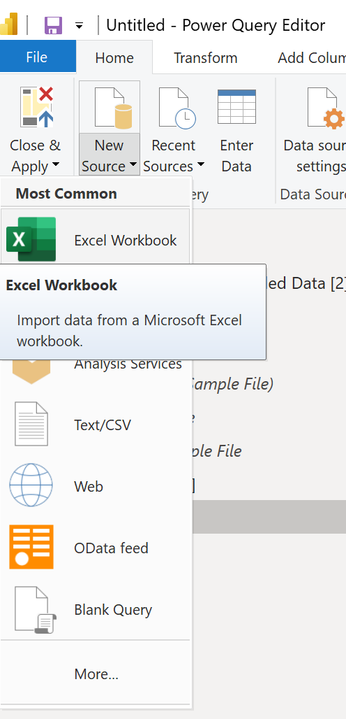
- Navigate to the folder ‘Population’ and select the excel file called ‘Local Authorities’. This file holds a breakdown of the population by each Local Authority.
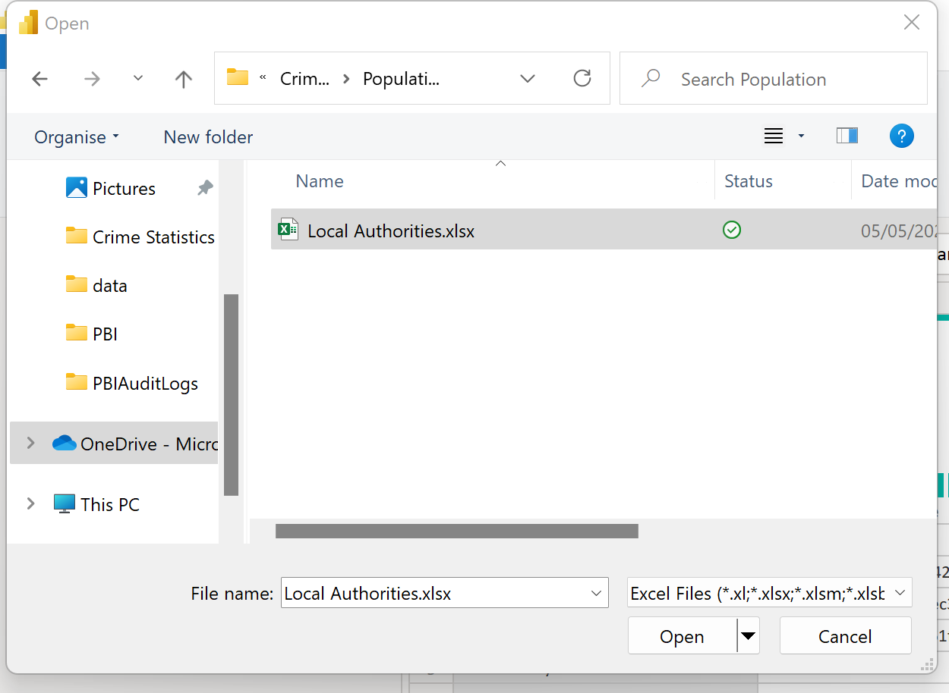
- In the navigation window select ‘Sheet 1’. You can preview the data here too before clicking ‘OK’.
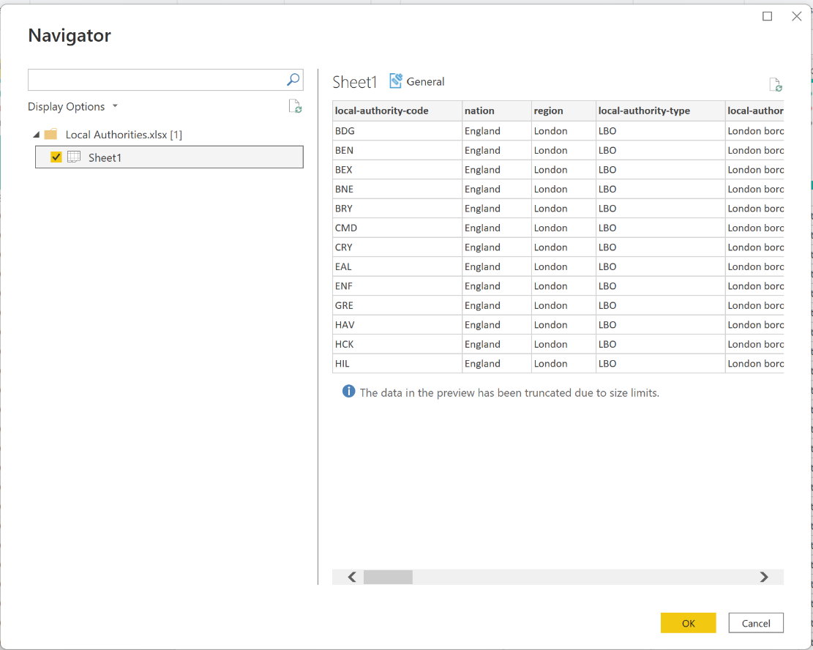

- You should now have two query tables that look like this in Power Query Editor:
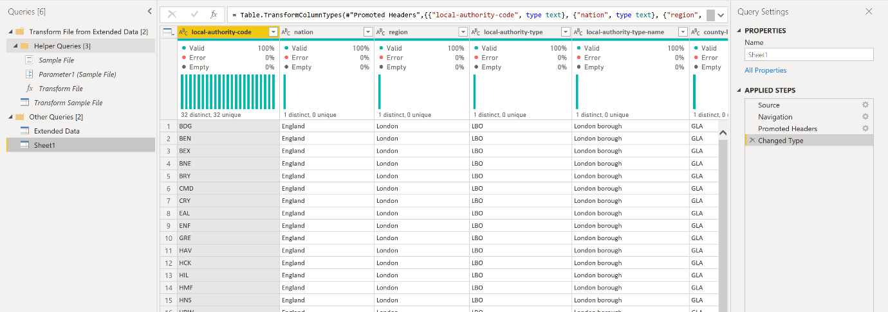

- We have now finished importing data to Power BI. Now would be a good time to save your file. Click on ‘Closed and Apply’ and then once the model has loaded (this might take a few minutes!), click on ‘Save’ and call your file ‘London Crime Statistics’.
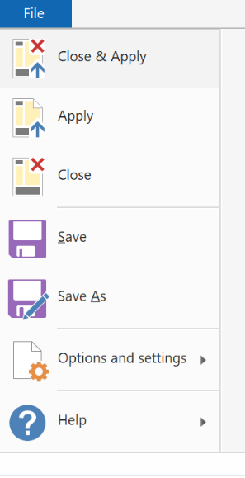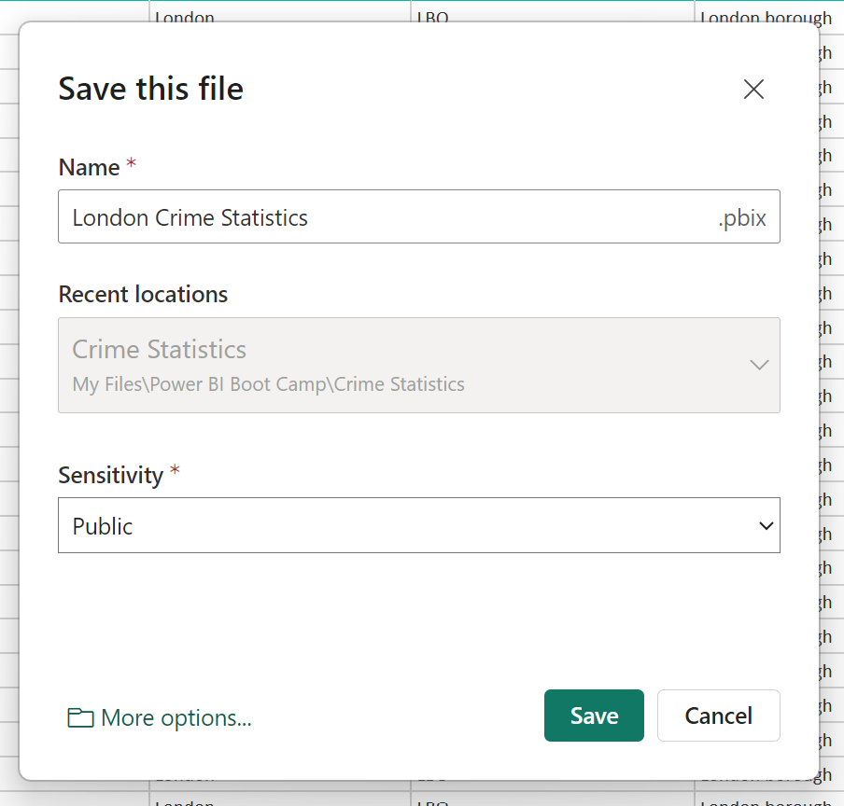
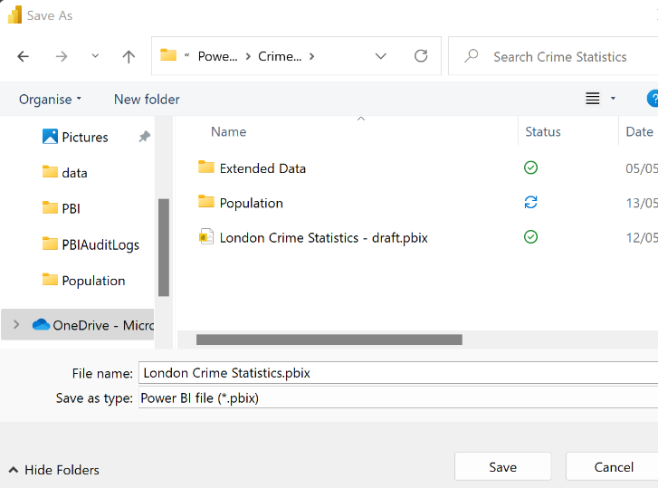

Shaping Data
Now that we have configured our data sources, we will want to shape our data so it is more manageable and easier to model. This normally involves renaming and removing unwanted columns as well as merging some of the queries and tables together. By only keeping the data that we need, we can not only make it easier to model and visualize the data but also improve the performance. This will also help when using the question and answer visual (If you are using the Power BI Service – this visual is not available in Report Server) which is explained later in this document.
This data set is already quite clean but normally the data sources will require a lot of cleaning with renaming queries and columns, removing null values and correcting data types.
To shape our data, we need to go back into the Power Query Editor. To do this, click on the ‘Transform Data’ button within Power BI Desktop.
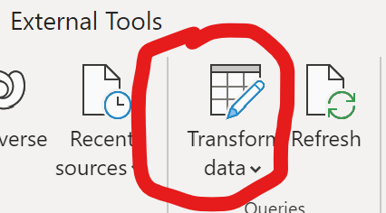

Rename Queries
We need rename our data tables to something more recognizable.
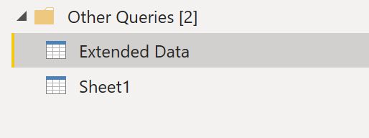
Name the queries as follows by right-clicking on each table and selecting ‘rename’.
Extended > Crime
Sheet1 > Population
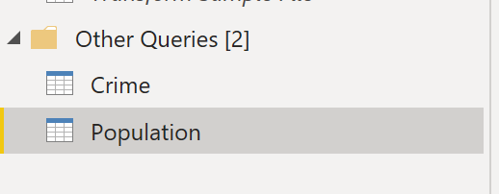

Removing Columns:
To remove Columns, simply right-click on each column in a table and select ‘remove’, or highlight all the columns you want to remove and then click ‘Remove Columns’. Or if you know which columns you want to keep, you can even highlight these columns and then click on ‘Remove Other Columns’.
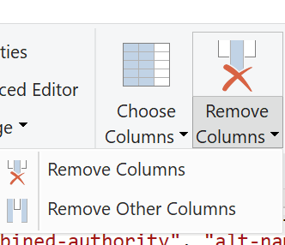

For this report, we will not need the following columns:
Crime:
“Source.Name”,
“Last Outcome Category”,
“Context”
Population:
We only want to KEEP 3 columns: (This time use ‘REMOVE OTHER COLUMNS’ function)
“LocalAuthorityName”
“gss-code”
“Population”

Rename Columns
The next step is rename all the columns in your tables so that make more sense. This will mainly involve renaming the columns into plain English so that they are easier to read but also so we can use Natural Query Language on our model later on (More on that later).
For Example, If you have a Customer Table, you can rename them like so:
FirstName = First Name
LastName = Last Name
BirthDate = Birth Date
Do this to all your remaining columns in your tables/queries. Concentrate on the Columns that you know you are likely to use in your visuals and filters as these will be visible to the consumers of the reports.
Crime
You do not need to rename anything yet.
Population
Rename ‘LocalAuthorityName to ‘Local Authority Name’
Rename ‘gss-code’ to ‘LSOA Code’

Change Data Types
It is quite common to have incorrect data types in spreadsheet and CSV data. i.e. the numerical data is displaying as text/string data types. To create visuals on this data, we need to change these columns to better formatted data types.
When you load data into Power BI Desktop, it will attempt to convert the data type of the source column into a data type that better supports more efficient storage, calculations, and data visualization. For example, if a column of values you import from Excel has no fractional values, Power BI Desktop will convert the entire column of data to a Whole Number data type, which is better suited for storing integers.
This concept is important because some DAX functions have special data type requirements. While in many cases DAX will implicitly convert a data type for you, there are some cases where it will not. For instance, if a DAX function requires a Date data type and the data type for your column is Text, the DAX function will not work correctly. So, it’s both important and useful to get the correct data type for a column. Implicit conversions are described later in this article.
As we are using a well-formed data for our PoC, most of the data types are already detected correctly and used in Power BI. But please wary of when using data sources such as Excel, CSV files, SharePoint Lists and Web Pages as Power BI doesn’t always detect the correct data type and this will need to be selected whilst shaping data.
More information on Data Types can be found here:
https://docs.microsoft.com/en-us/power-bi/connect-data/desktop-data-types

- In the ‘Crime’ table, just make sure the ‘date’ field has a data type of ‘Date’ (not datetime or text).
- In the ‘Population’ table, make sure that the ‘population’ filed has a data type of ‘whole number’.

Remove Nulls/Replace Values
Nulls don’t play well with Power BI and they could cause errors in your results or break visuals. Go through each table paying close attention to the ‘Column Distribution’ data at the top of each column. Any column that shows ‘empty values’ in the visual should be changed.
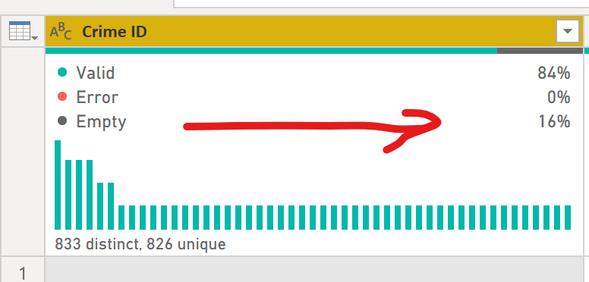

From the ‘Transform’ ribbon, select ‘Replace Values’ (or Right-click on each column and select ‘replace values’).
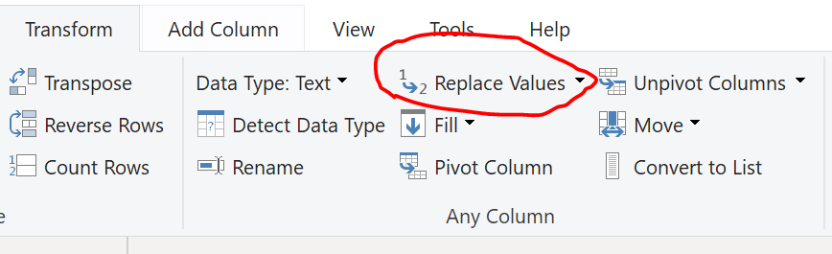
You should replace each value with a suitable alternative. For example, for text, replace nulls with ‘Unknown’, and for numerical data, replace nulls with ‘0’.
Crime
Replace Blanks in ‘Crime ID’ Only
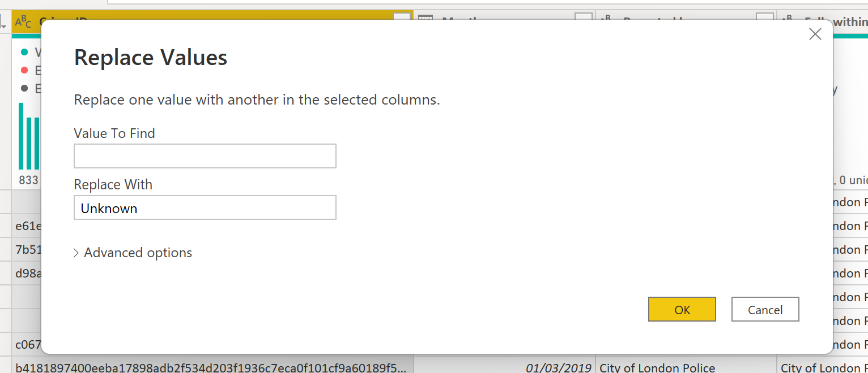

Split Column
In the ‘Crime’ table, we need to split the ‘LSOA Name’ so the location of the crime makes more sense. Click on ‘Split Column’ and then ‘Split Column by Non-Digit to Digit’.
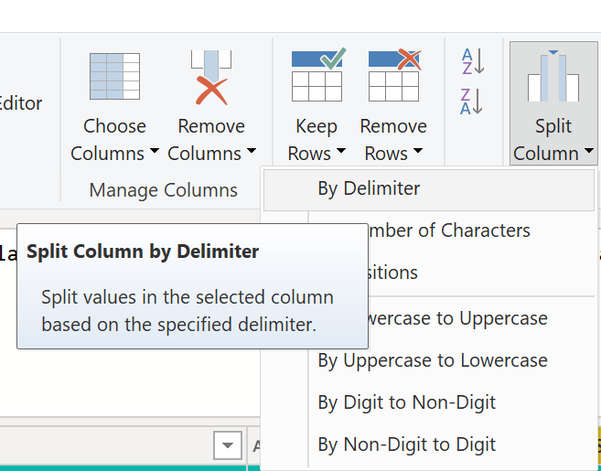
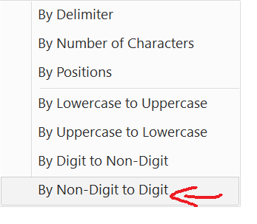
You should now have 2 Columns. Rename ‘LSOA name.1’ to ‘Local Authority Name’ and you can remove ‘LSOA.name.2’ as we no longer need this.

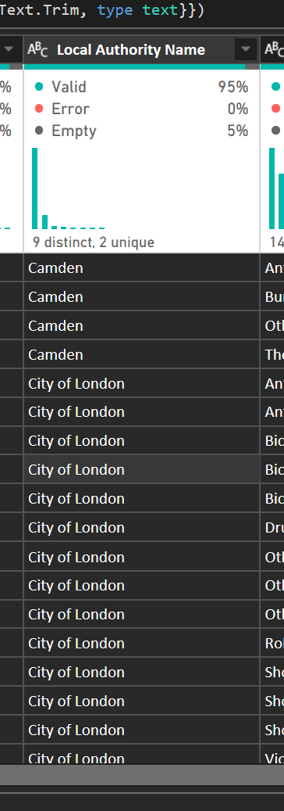

Trim Data
The previous step where we split the column has left an invisible ‘white space’ at the end of the column ‘Local Authority Name’. Click on the ‘Format’ option and select ‘Trim’ to remove this.

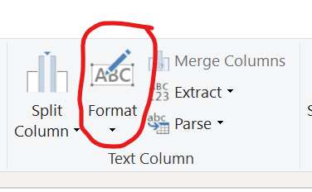
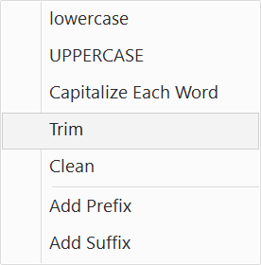

Merge Queries
We want to simplify our model as much as possible so we will now merge the population data from the Population Table into the Crime Table. We are also interested only in crimes committed within London so this will reduce the amount of data we are reporting on which will improve the overall performance.
- Highlight the Crime Table and Select ‘Local Authority’ column. Next click on the ‘Merge Queries’ button.
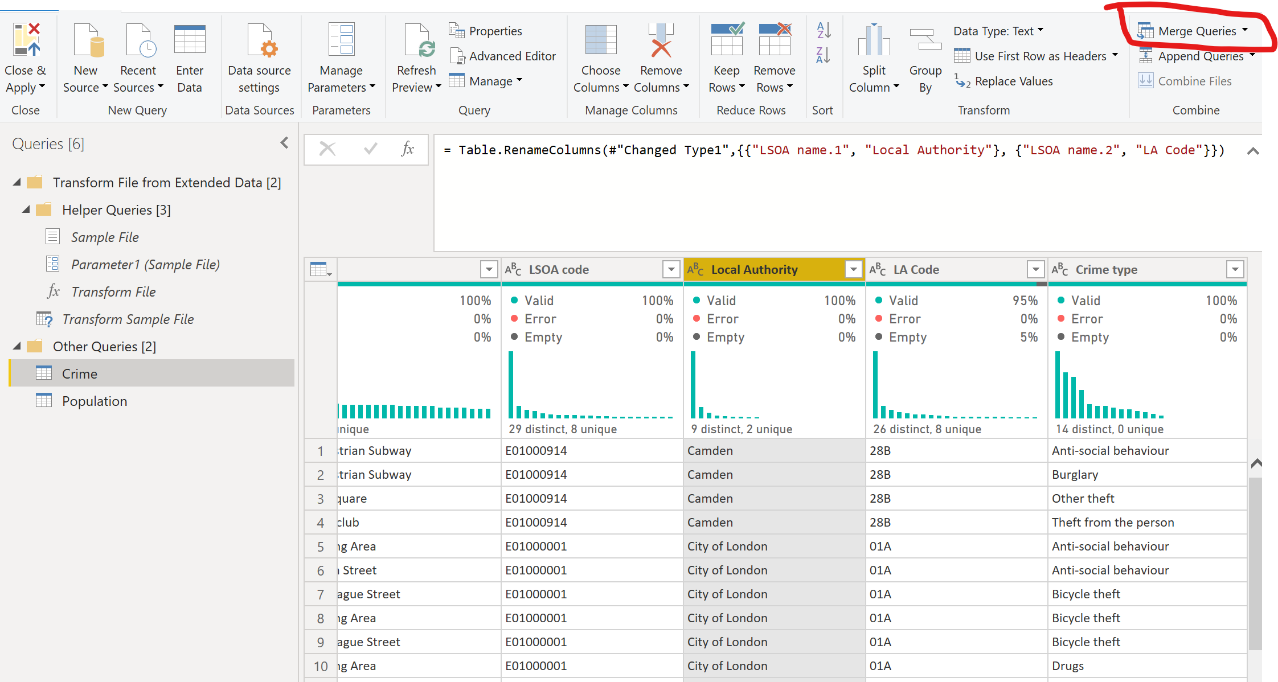
- Select the ‘Local Authority’ column for the Crime table and the ‘Local Authority’ Column in the Population table. Make sure the Join Kind is set to ‘Inner (only Matching rows)’. 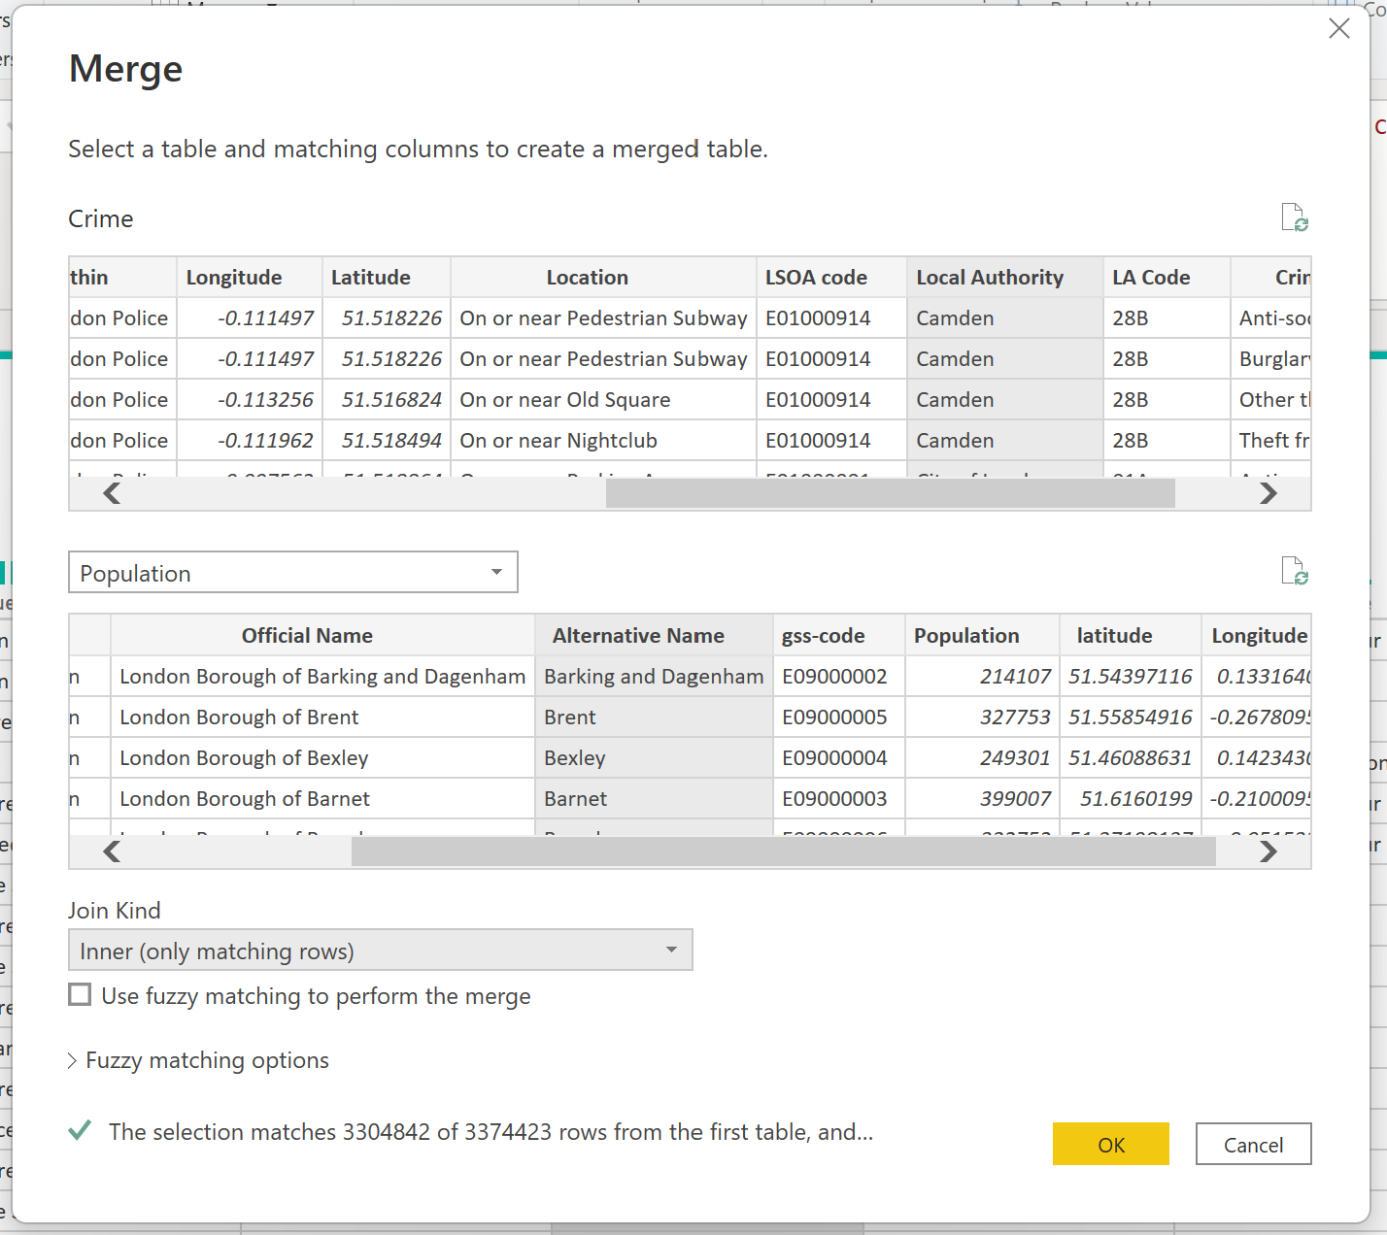

- Press OK and wait for your model to update. This may take a few minutes as you are reducing the number of rows in the Crime table.

- Now, you will see a new column with a table icon next to it, if you click on the arrows to expand the data, you can then select the ‘Population’ column. This is the column from the Population table, and this will now merge into your Crime table.
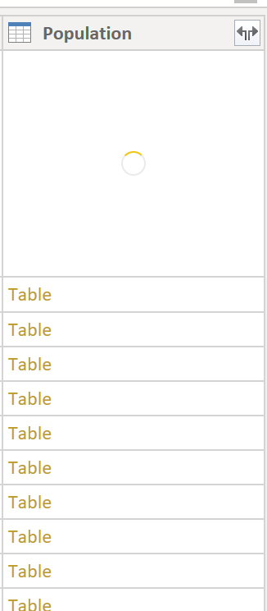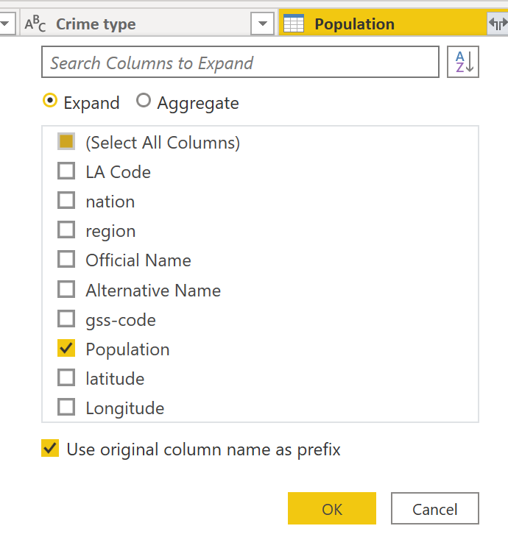
- Rename the column to ‘Population’.
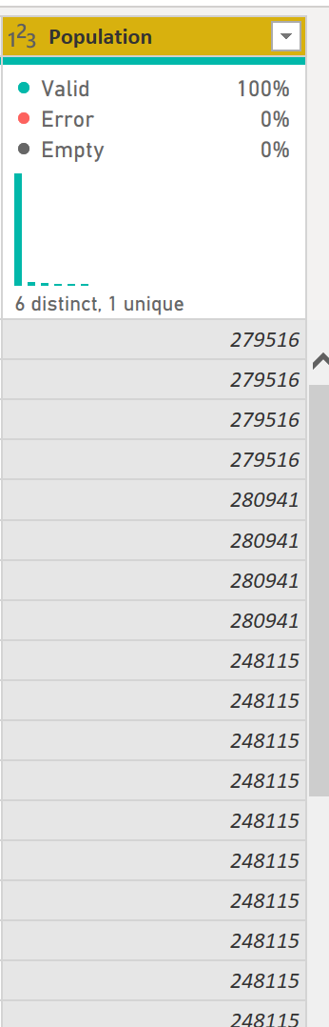

Finishing Up
Once we are happy with the shape of our model, we can close the editing frame, apply the changes to the model and save the report, ready for the next part.
Click on File and select ‘Close and Apply’. It will take a few minutes to update your model.
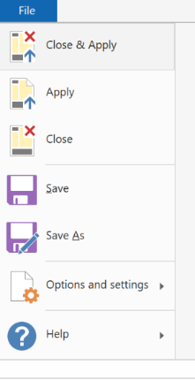
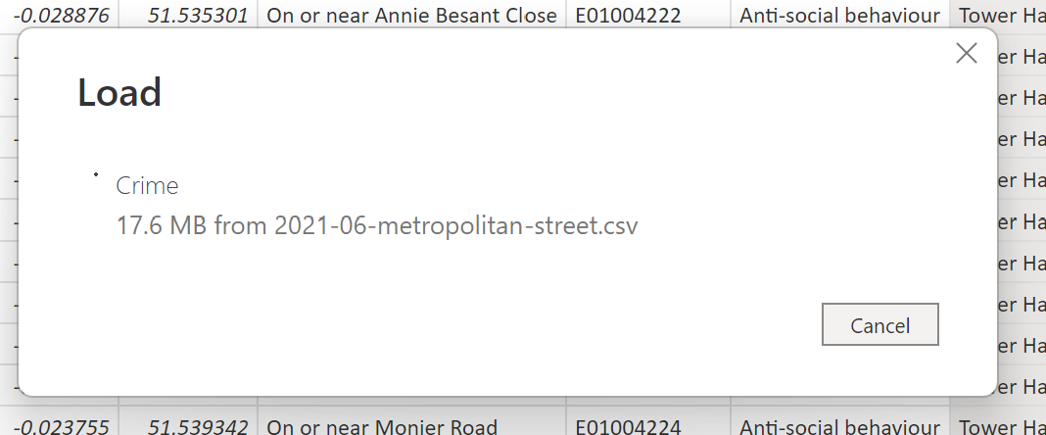
Now we can save the report. Click on ‘Save’

Relationships
We now need to check that we have relationships between all our tables. Power BI can auto-detect these but sometimes needs a little help depending on the data sources, data types and column naming conventions.
Relationships between tables are necessary to accurately calculate results and display the correct information in your reports.
Click on the ‘Model’ button to check the current relationships in the model diagram. Yours should look like this:
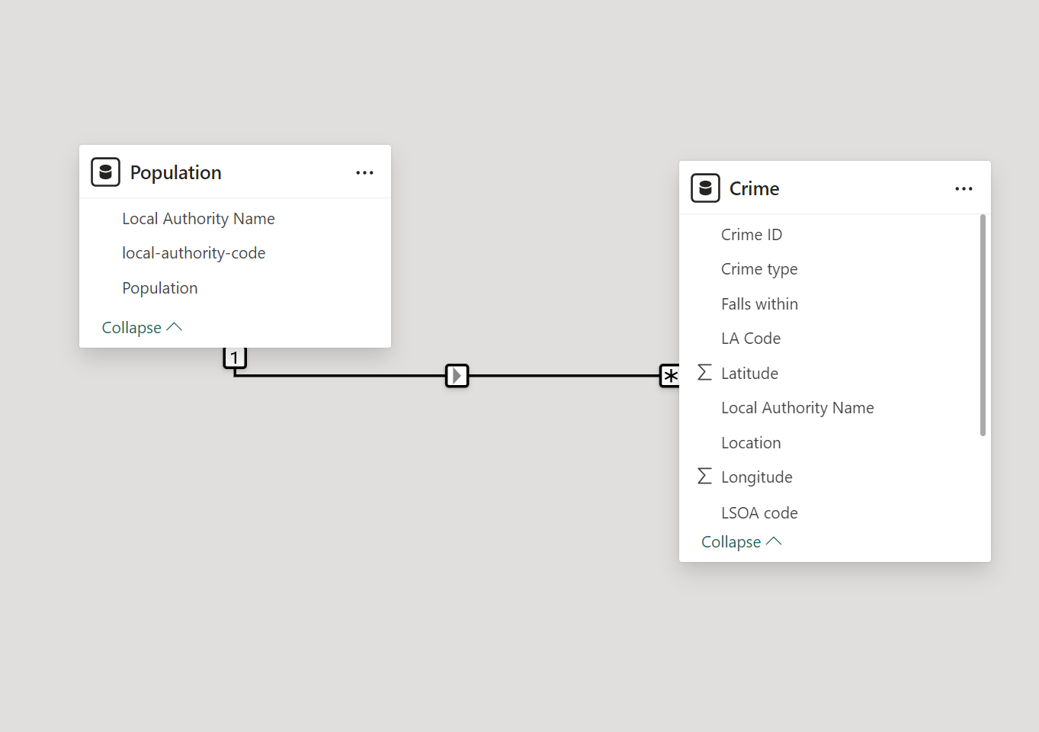
You can also see your relationships by clicking on the ‘Manage Relationships’ button in the Model menu.
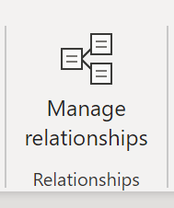
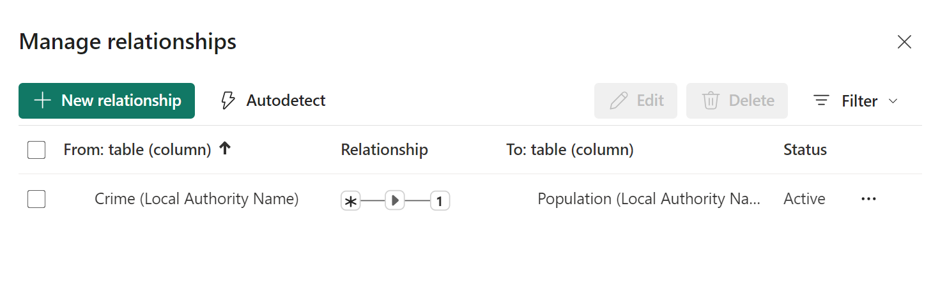

Configure additional options
When you create or edit a relationship, you can configure additional options. By default, Power BI Desktop automatically configures additional options based on its best guess, which can be different for each relationship based on the data in the columns.
Cardinality
The Cardinality option can have one of the following settings:
Many to one (*:1): A many-to-one relationship is the most common, default type of realtionship. It means the column in a given table can have more than one instance of a value, and the other related table, often know as the lookup table, has only one instance of a value.
One to one (1:1): In a one-to-one relationship, the column in one table has only one instance of a particular value, and the other related table has only one instance of a particular value.
One to many (1:*): In a one-to-many relationship, the column in one table has only one instance of a particular value, and the other related table can have more than one instance of a value.
Many to many (*:*): With composite models, you can establish a many-to-many relationship between tables, which removes requirements for unique values in tables. It also removes previous workarounds, such as introducing new tables only to establish relationships. For more information, see Relationships with a many-many cardinality.
Cross filter direction
The Cross filter direction option can have one the following settings:
Both: For filtering purposes, both tables are treated as if they're a single table. The Both setting works well with a single table that has a number of lookup tables that surround it. An example is a sales actuals table with a lookup table for its department. This configuration is often called a star schema configuration (a central table with several lookup tables). However, if you have two or more tables that also have lookup tables (with some in common) then you wouldn't want to use the Both setting. To continue the previous example, in this case, you also have a budget sales table that records target budget for each department. And, the department table is connected to both the sales and the budget table. Avoid the Both setting for this kind of configuration.
Single: The most common, default direction, which means filtering choices in connected tables work on the table where values are being aggregated. If you import a Power Pivot in Excel 2013 or earlier data model, all relationships will have a single direction.
For further information on Power BI relationships. Please see below link:
https://docs.microsoft.com/en-us/power-bi/transform-model/desktop-create-and-manage-relationships

Modeling Data

Create a Date Dimension Table
- Click on ‘New Table’
- Enter the following Formula:
Date = CALENDAR(Min(Crime[Month]),MAX(Crime[Month]))

- You should have a date table that looks like this:
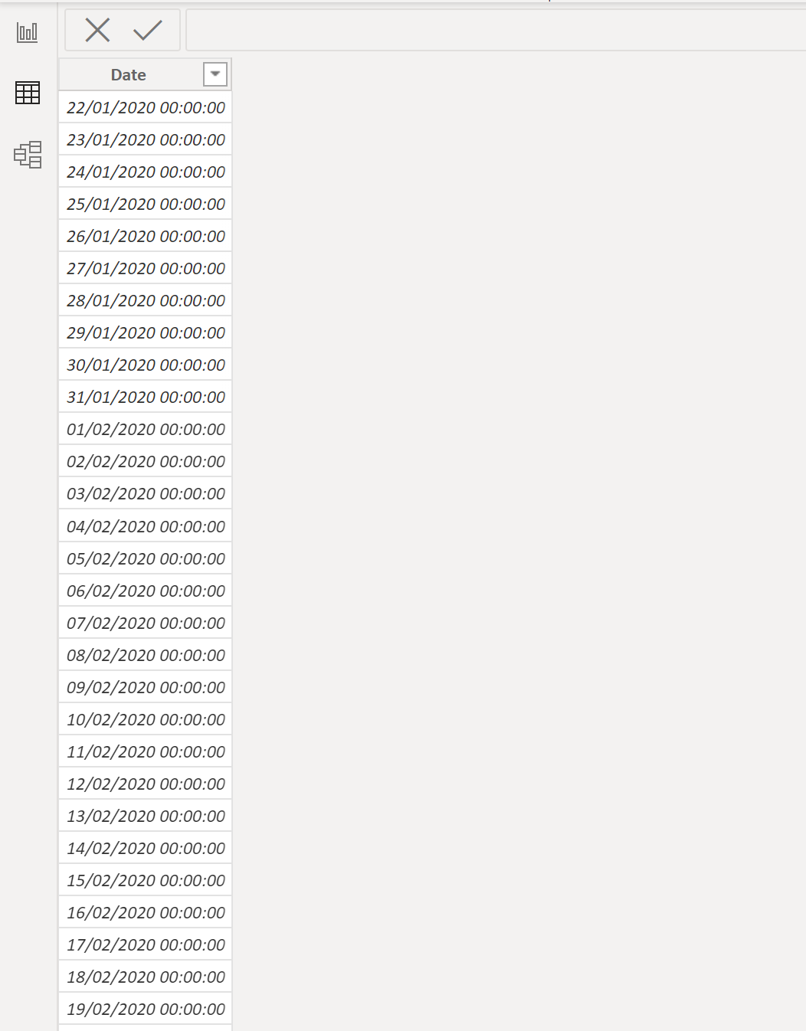

- Change the data type to ‘date’
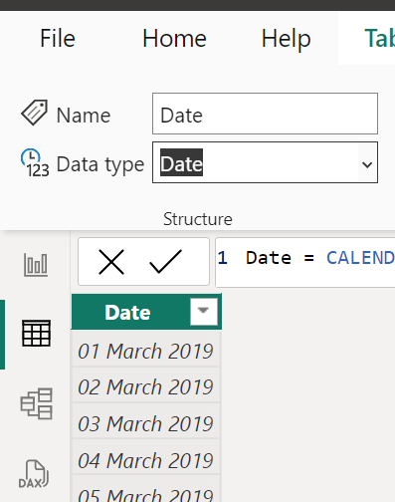
- Now add the following ‘New Columns’:
Year = YEAR('Date'[Date])
Month = FORMAT('Date'[Date],"MMMM")
Month Number = MONTH('Date'[Date])
Weekday Number = WEEKDAY('Date'[Date],1)
Day = FORMAT('date'[Date],"dddd")

Create Monthly Bins
This is another important trick to use when you want to sort your data into month names chronologically.
Click on the ‘Date’ Column in your date table and select ‘New group’.
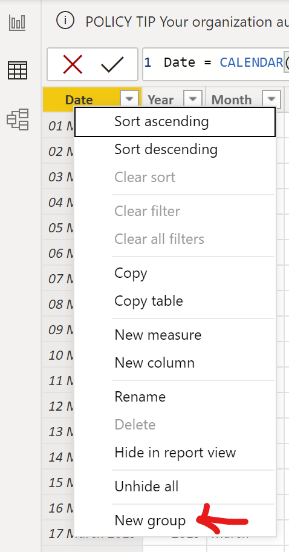

Give your new Group the name ‘Month & Year’ and make sure the Bin Size is set to ‘1’ and ‘Months’
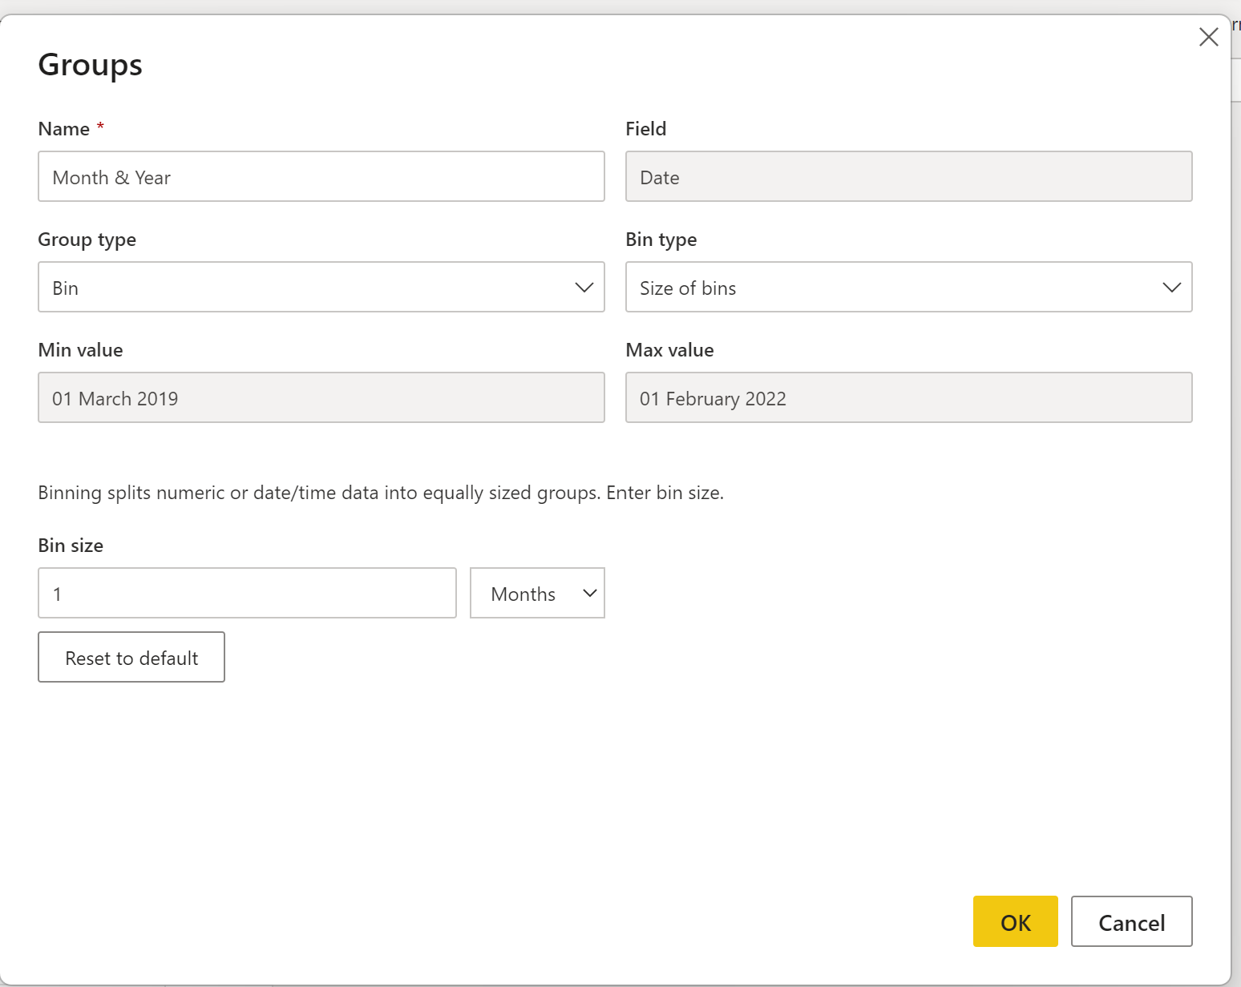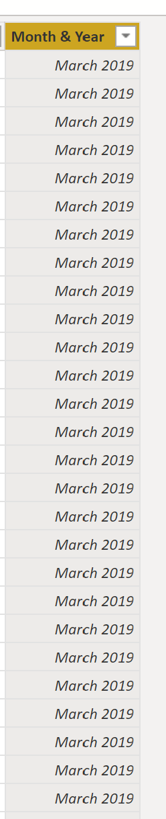
Finally, add a Relationship to the date table so that it connects to the Crime table as shown below:
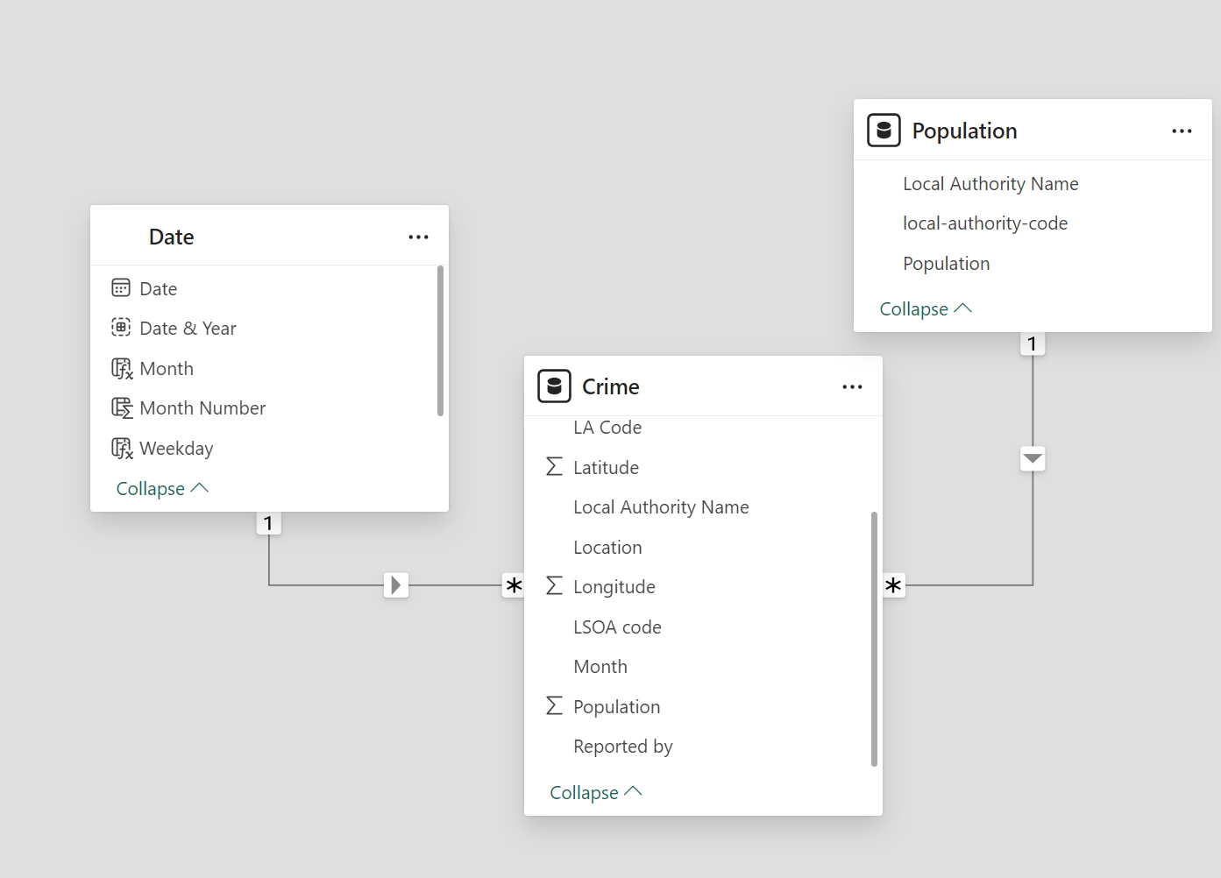

One last change to the relationships. We are going to make the relationship between Crime and Population bi-directional so that we can filter data on both tables (this will become more apparent when we start building the reports.
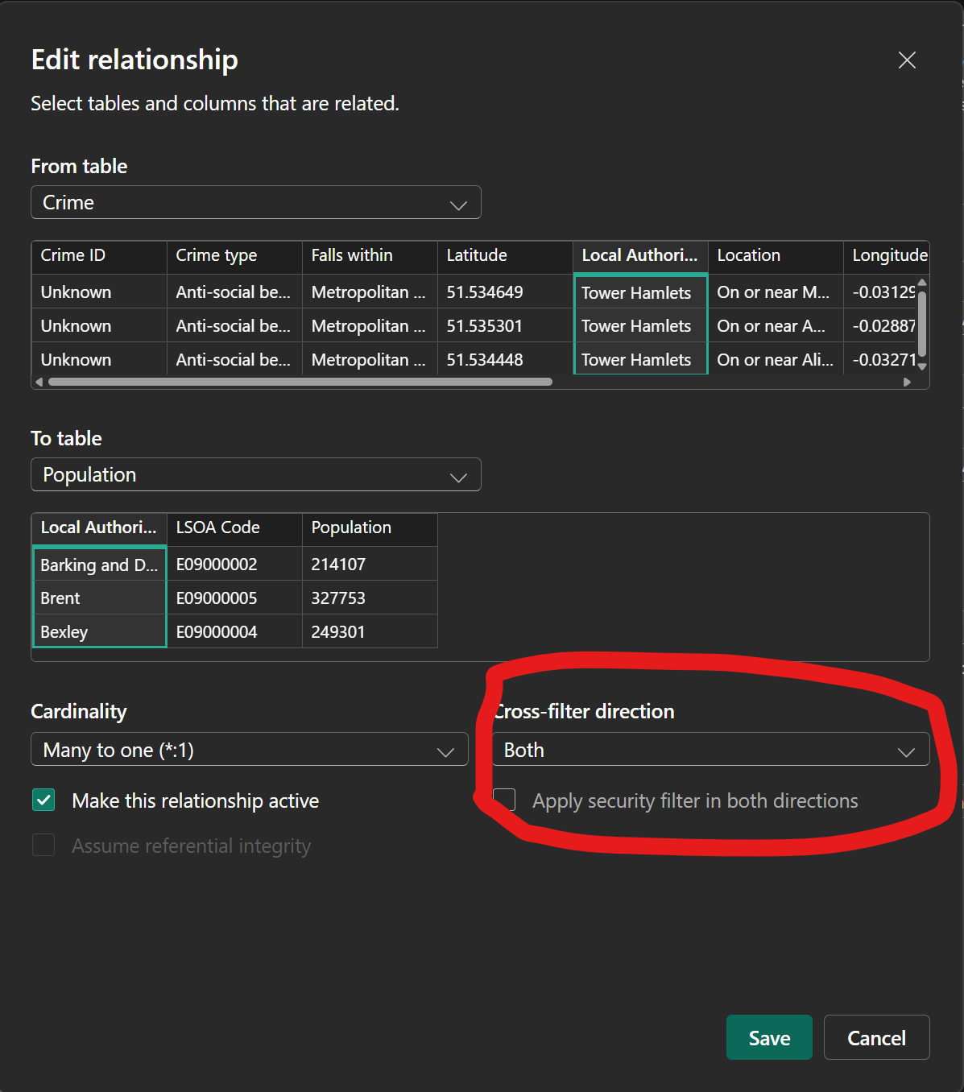

Data Categorization
This will help Power BI how to treat data when creating some visualizations. Namely for geographic visuals.
- Make sure you are in the Data or Report view and that you are looking at the Crime Query/Table.
- Highlight the ‘Local Authority’ and then select ‘City’ from Data Category. A little Globe Icon should appear next to that column:
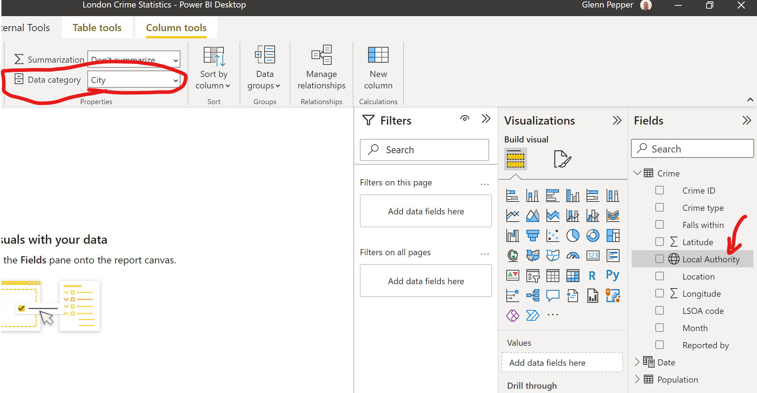
- Now go to the Latitude Column and Select ‘Latitude’ from the Data Category. Repeat this step for Longitude. You should now have to globe icons next to these columns.
- Finally Repeat this step with the ‘LA Code’ field, this time choosing ‘State or Province’ for the Data category.
Data categorization in Power BI Desktop - Power BI | Microsoft Docs

Hierarchies
Hierarchies provides the ability to drill down within a Power BI report. When a visual has a hierarchy, it enables the ability to drill down for additional relevant details.
You will notice that Dates fields automatically create hierarchies by default:
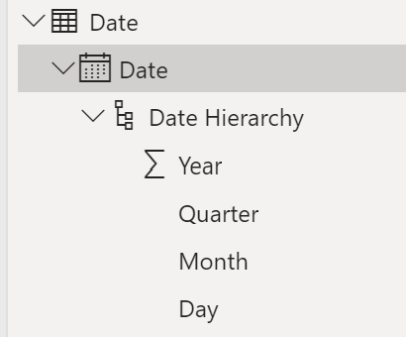
We can create another Hierarchy with our Location Data.
- Highlight the Column ‘Local Authority’ in the data or report view, right-hand click on the column and select ‘Create Hierarchy’.
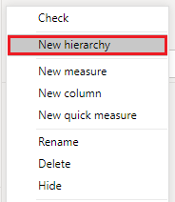
- You should now see the hierarchy as part of your table:
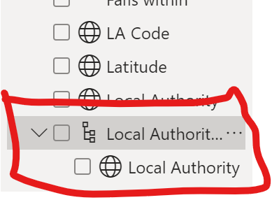
- Right-Hand Click on ‘LA Code’ and select ‘Add to Hierarchy’ and choose the Local Authority Hierarchy you just created.
- Finally do the same for the location. Your hierarchy should look like this:
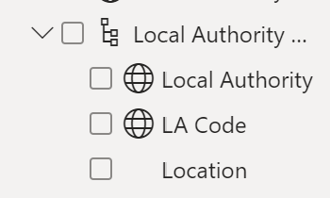

DAX CALCULATIONS
DAX is a collection of functions, operators, and constants that can be used in a formula, or expression, to calculate and return one or more values. Stated more simply, DAX helps you create new information from data already in your model. It will summarize and aggregate your data into new columns (calculated columns) or measures.
You don’t necessarily need to use DAX calculations to create visuals and tell stories about your data but it will great enrich the data and help your create more powerful data stories and visuals.
This section will help you create some DAX calculations in measures which can then be used in your final report to create more detailed visualizations.
To understand more about the DAX basics, then please read the following document:
DAX basics in Power BI Desktop - Power BI | Microsoft Docs

Measures
Measures are used in some of the most common data analyses. Simple summarizations such as sums, averages, minimum, maximum and counts can be set through the Fields well. The calculated results of measures are always changing in response to your interaction with your reports, allowing for fast and dynamic ad-hoc data exploration. Let’s take a closer look. For more information, see Create measures.
To create a measure, you can simply click on the ‘New Measure’ button in the ‘Table Tools’ ribbon, or by right-hand clicking on a table and selecting ‘New Measure’.
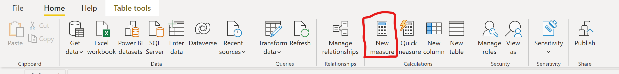
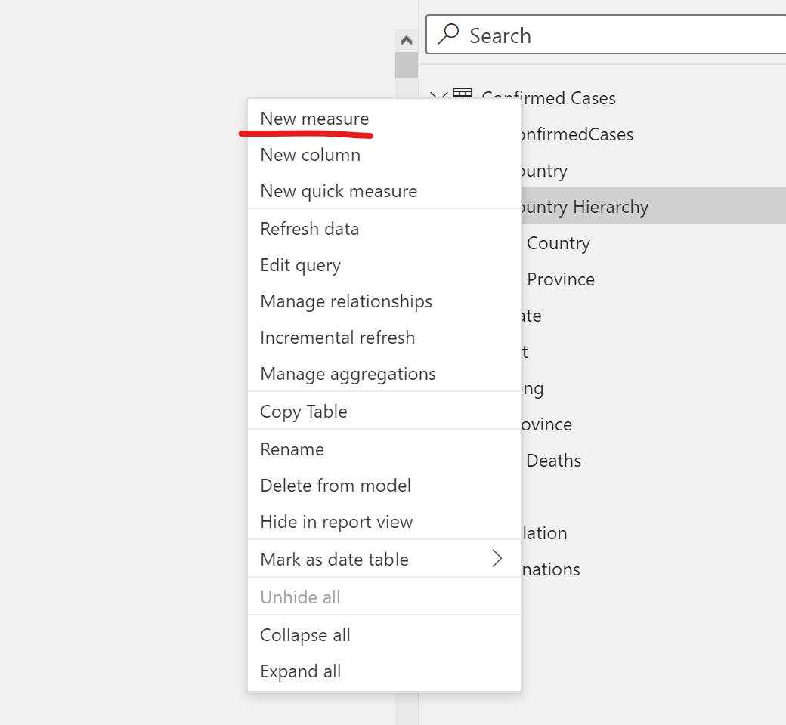

Population
- Total Population
Total Population = SUM(Population[Population])
- Total Population (unfiltered)
Total Population (Unfiltered) = CALCULATE(SUM(Population[Population]), ALL(Population[Local Authority Name]), ALL('Date'))

Question: - Why do we have two measures for Total Population?
- % of Total Population
% of Total Population = DIVIDE(Population[Total Population],Population[Total Population (Unfiltered)])

Crime
- Total Crime
Total Crime Count = COUNTROWS(Crime)
- Total Crime (Unfiltered)
Total Crime (Unfiltered) = CALCULATE(CountRows(Crime), ALL(Crime[Local Authority Name]), ALL('Date'), ALL(Crime[Crime type]))
- Crime Rate (Per 1000)
Crime Rate (Per 1000) = DIVIDE([Total Crime Count],SUM('Population'[Population]))*1000
- % of Total Crime
% Total Crime = DIVIDE([Total Crime Count], [Total Crime (Unfiltered)])

- 12 Month Rolling Average
12 Month Rolling Average =
VAR _EndDate = Max('Date'[Month & Year])
VAR _12MonthsAgo = EOMONTH(_EndDate, -12)
VAR _StartDate = Date(Year(_12MonthsAgo), month(_12MonthsAgo),1)
VAR _Table =
Summarize(
Filter(All('Date'),[Month & Year] >= _StartDate && [Month & Year] <= _EndDate),
'Date'[Month & Year],
"_value",'Crime'[Total Crime Count])
Return
AverageX(_table,'Crime'[Total Crime Count])

Report Theme
With Power BI Desktop report themes, you can apply design changes to your entire report, such as using corporate colors, changing icon sets, or applying new default visual formatting. When you apply a report theme, all visuals in your report use the colors and formatting from your selected theme as their defaults. A few exceptions apply, which are described later in this article.
Report themes can be selected by navigating to the View ribbon, then selecting the drop-down arrow button in the Themes section of the ribbon, then selecting the theme you want. Available themes are similar to themes seen in other Microsoft products, such as Microsoft PowerPoint.
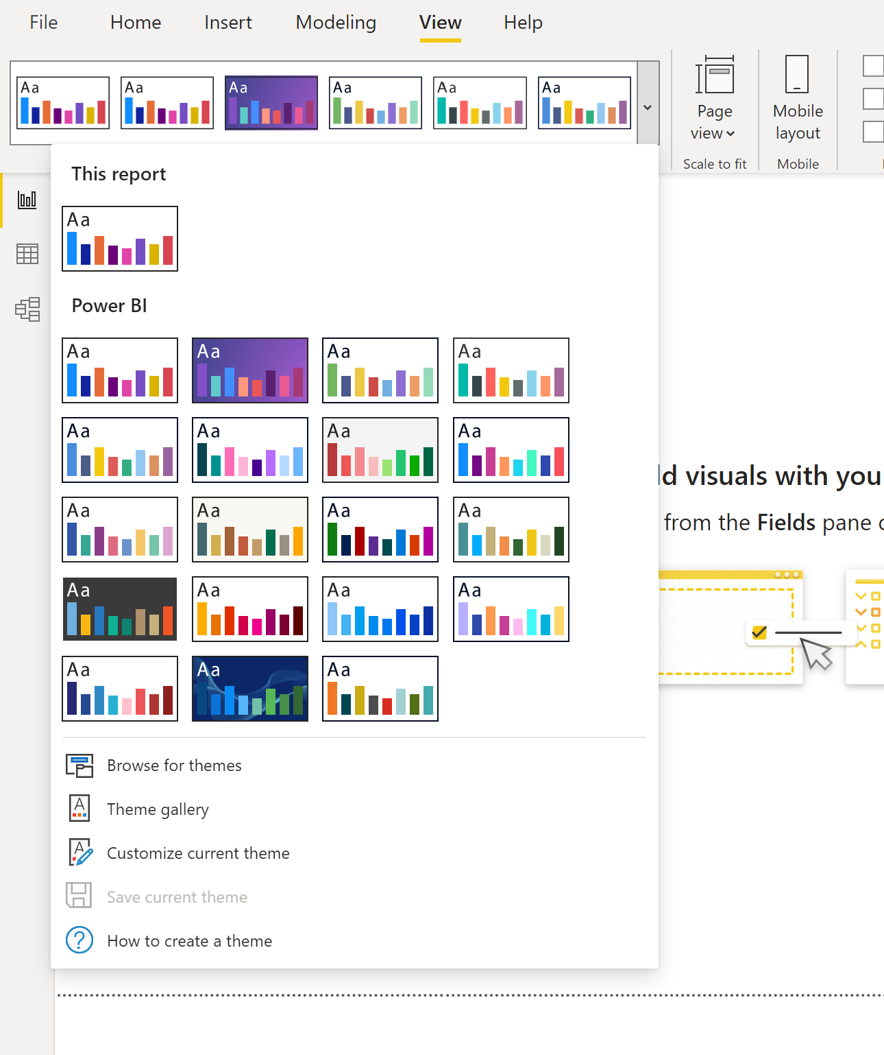
You can also browse theme gallery either through this theme menu or via the link below:
Themes Gallery - Microsoft Power BI Community
Once you have chosen a theme, you can edit it via the ‘Customize Current Theme’ option.
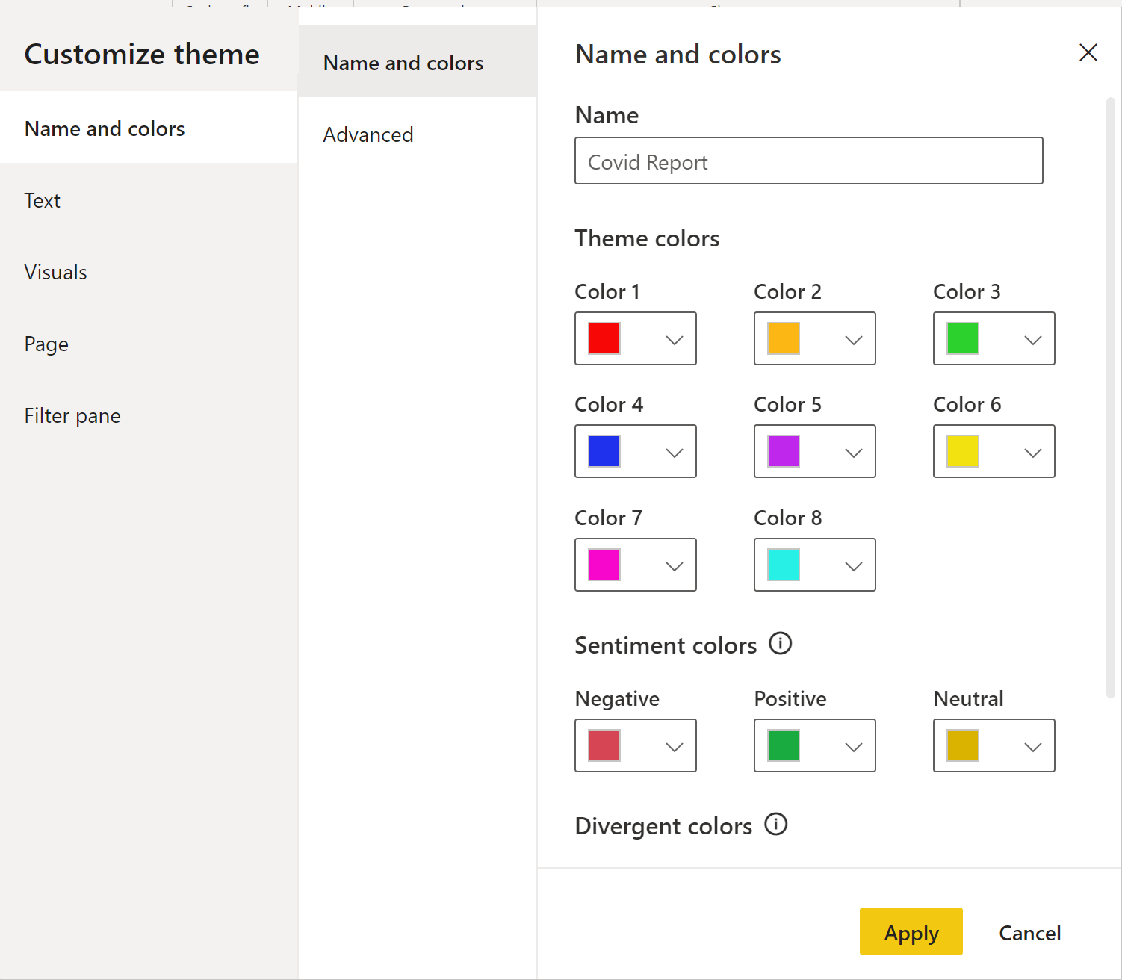

Please choose and edit a theme for your report – You can be as creative as you like!

Create your First Report Page
We are now going to create a report page which we will use as a template for other pages which will include navigation and shortcuts.
- Using the ‘shape’ tool, create a rectangle on the left hand side. We will use this to add a logo and some slicers.
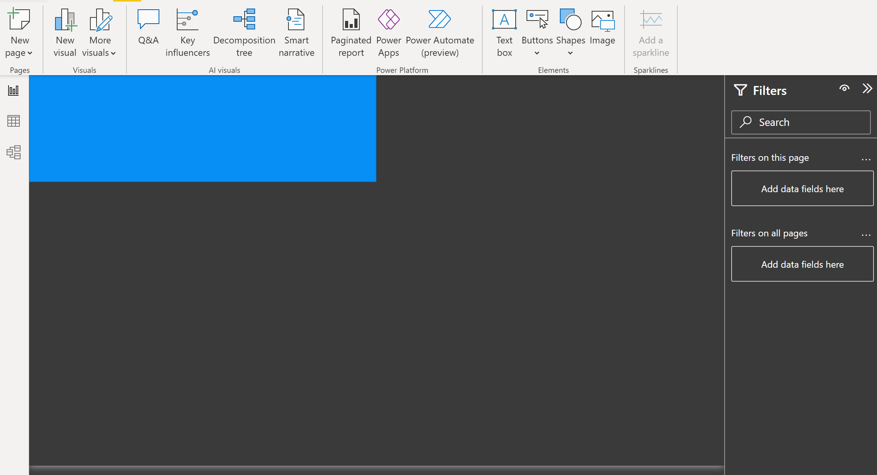

- Add an image to the rectangle and select the Metropolitan Police Image included with the report files:
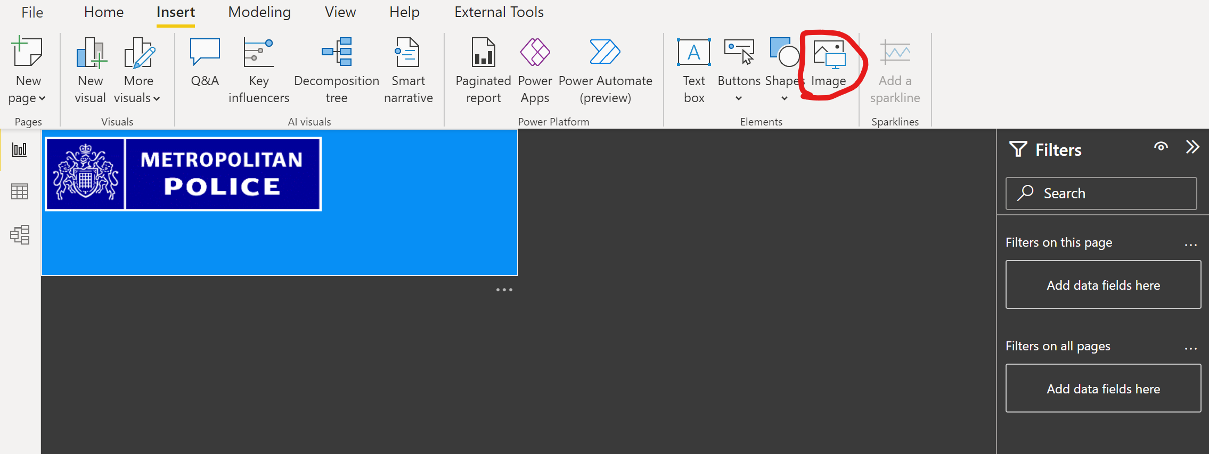
- Next, add a text box and copy the link to the data set into here as a reference:
Data downloads | data.police.uk
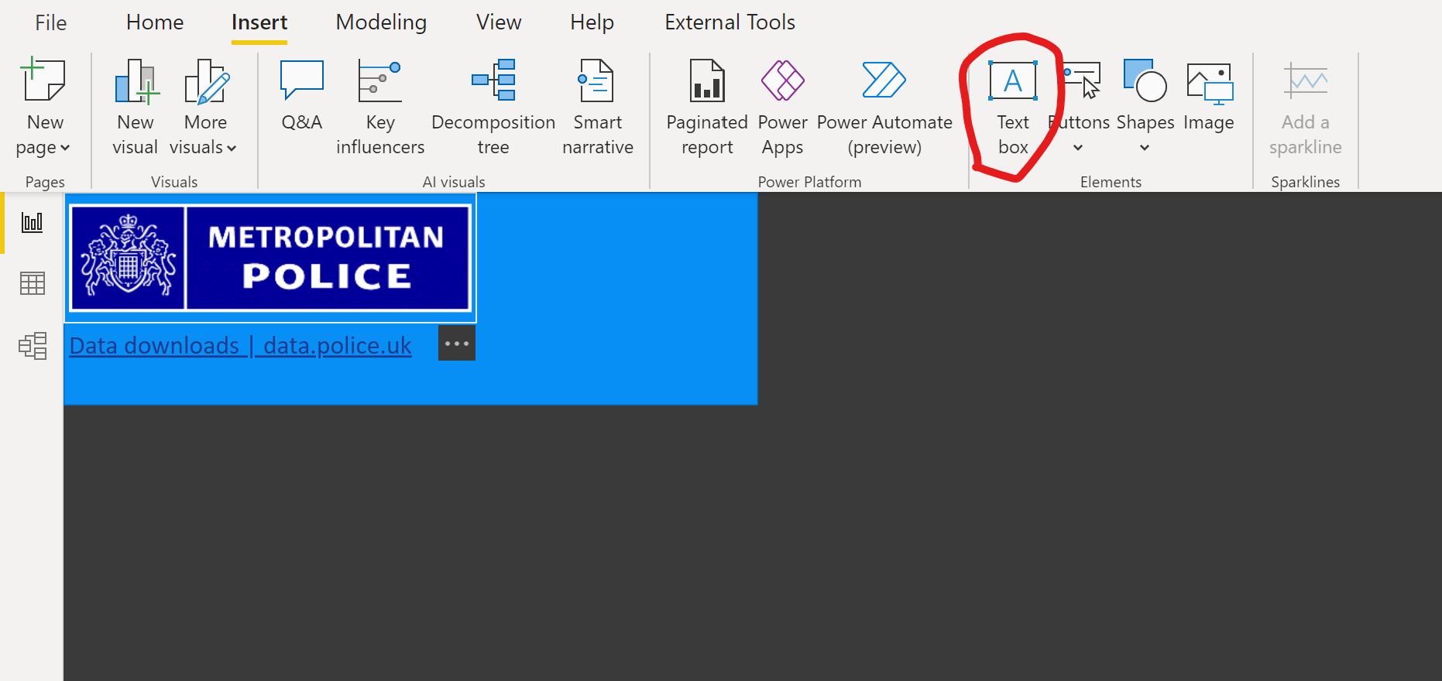
Make sure the rectangle shape is sent to the back of your report so your images and filters are visible You can do this via the ‘Format’ menu. Highlight the textbox and then press ‘Send to back’.
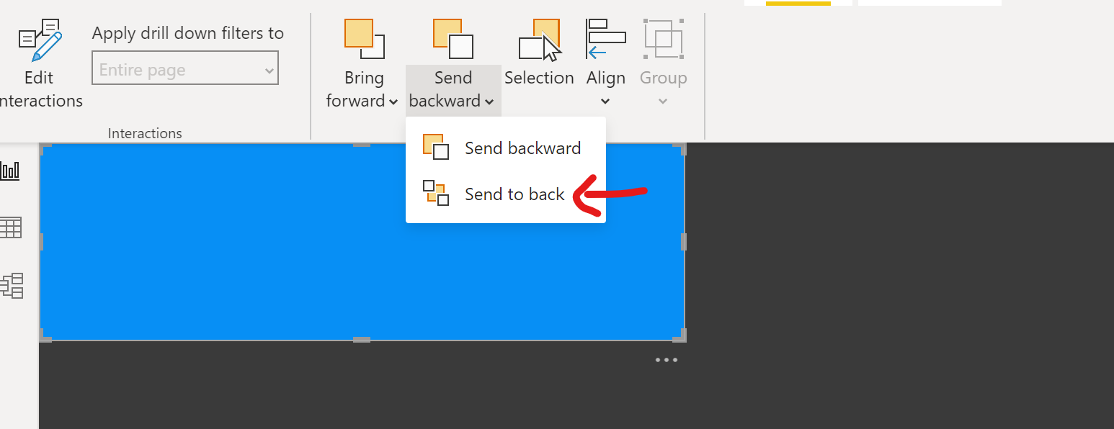

- Add a slicer to your navigation bar. This should be for ‘Date’[Year] column The slicer should appear as Tiles; As shown below:
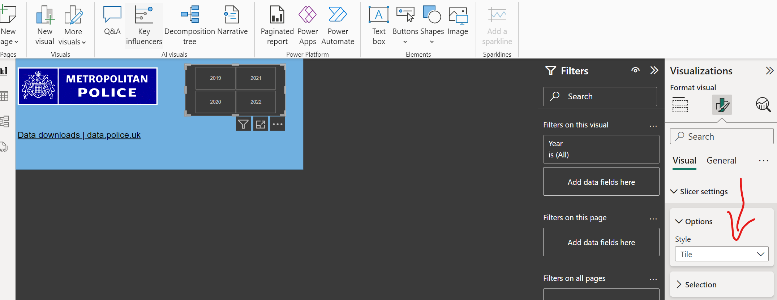
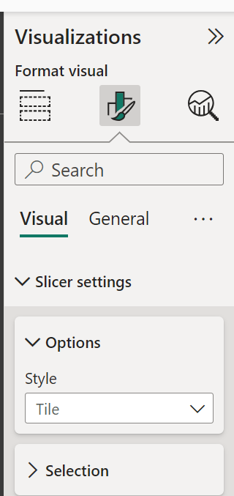
- Now add a slicer for the Local Authority
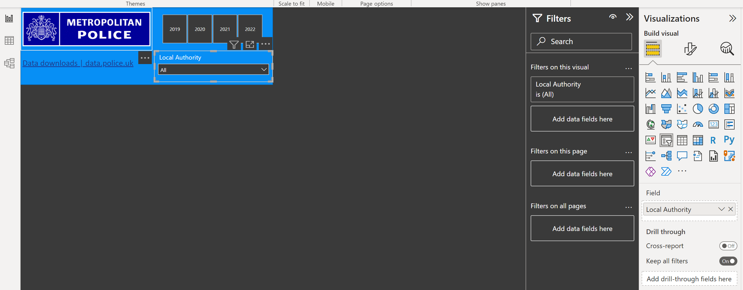

- Once you have aligned your slicers and buttons in the navigation bar, format them to your specifications. You can also group everything together so you can move your navigation around collectively to the best position. We can group items together by highlighting each button, slicer, text box and shape (ctrl and click) and then click on ‘Group’ in the format ribbon. This will allow us to format, move and resize buttons together.
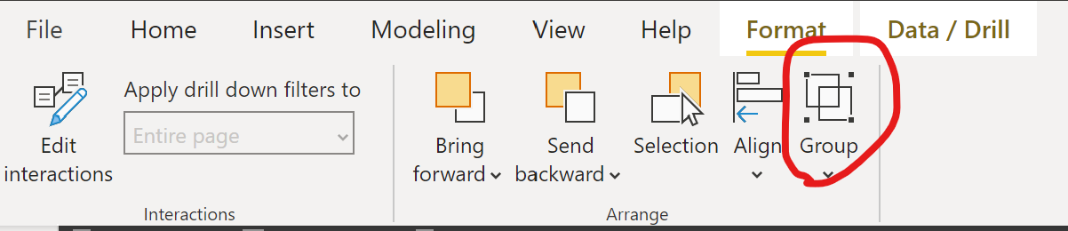
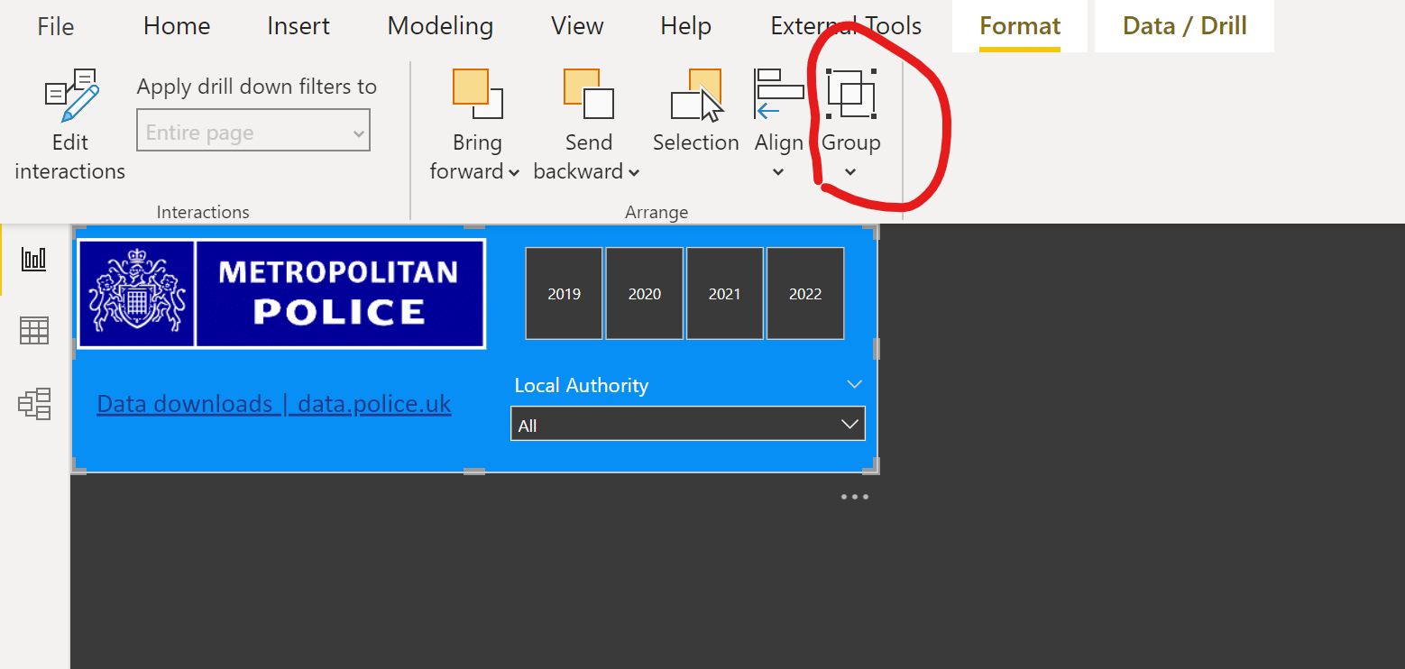

- Create a second Report Page and click on your grouped icons. Ctrl+C to copy and then paste these to your second report page.
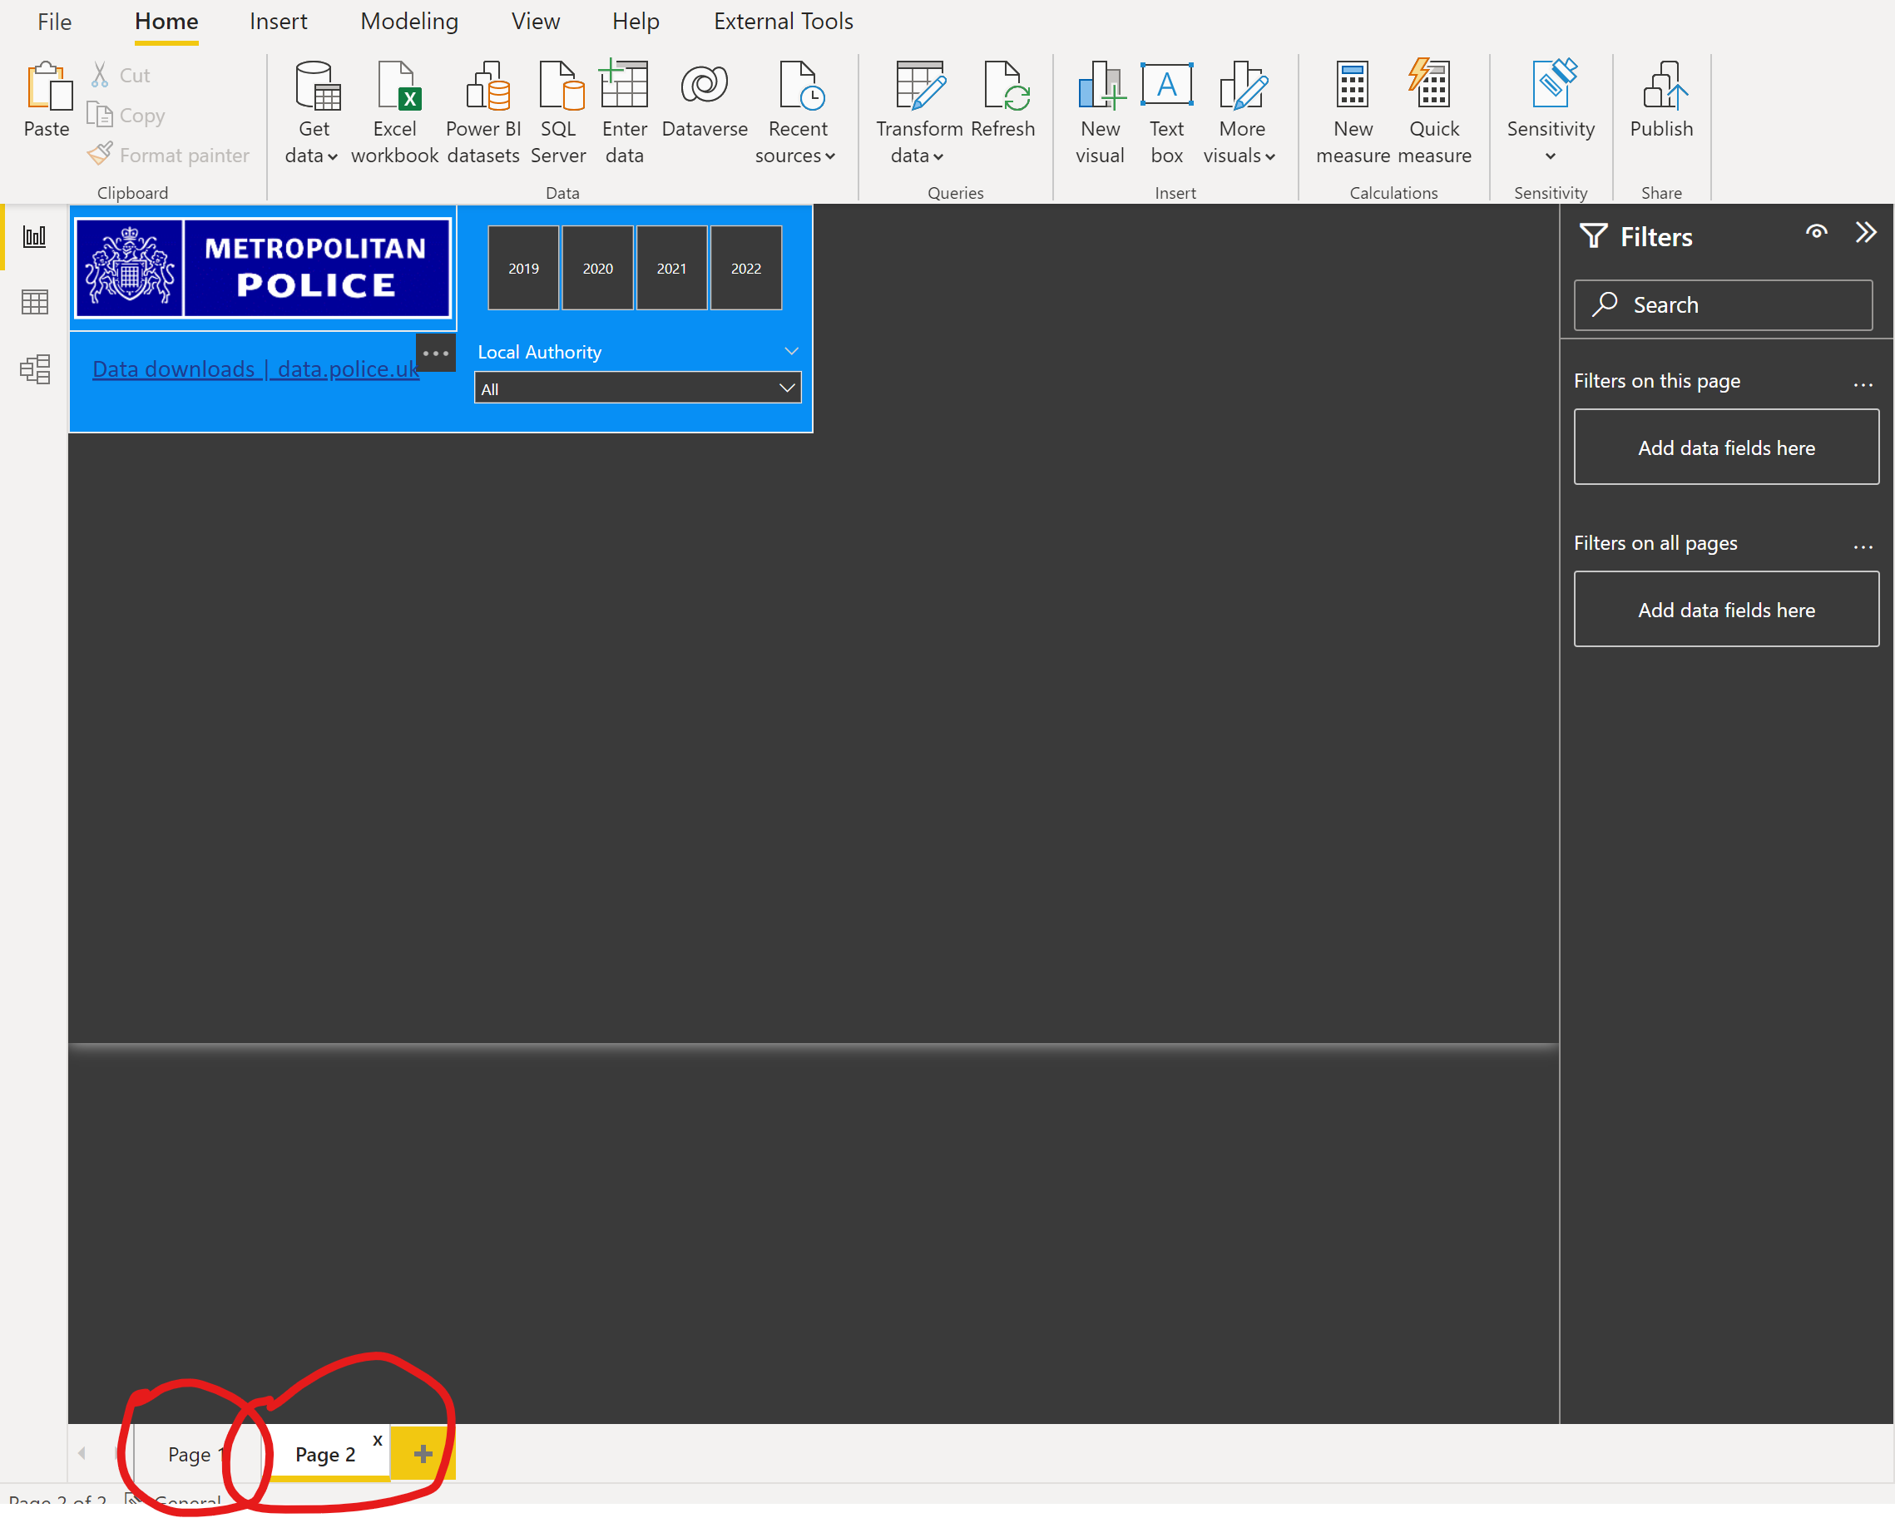
- Now would be a good time to save your report!

Visualizations

Custom Visual download
Power BI comes with many out-of-the box Power BI visuals. These visuals are available in the visualization pane of both Power BI Desktop and Power BI service, and can be used for creating and editing Power BI content.
Many more Power BI visuals are available from the Microsoft AppSource or through Power BI. These visuals are created by Microsoft and Microsoft partners, and are tested and validated by the AppSource validation team.
For more information on Custom Visuals, please visit https://docs.microsoft.com/en-us/power-bi/developer/visuals/power-bi-custom-visuals
Before we get started, we are going to download 2 custom visuals to use in our report.
To do this, click on the ellipses in the visualizations pane and select ‘get more visuals’.
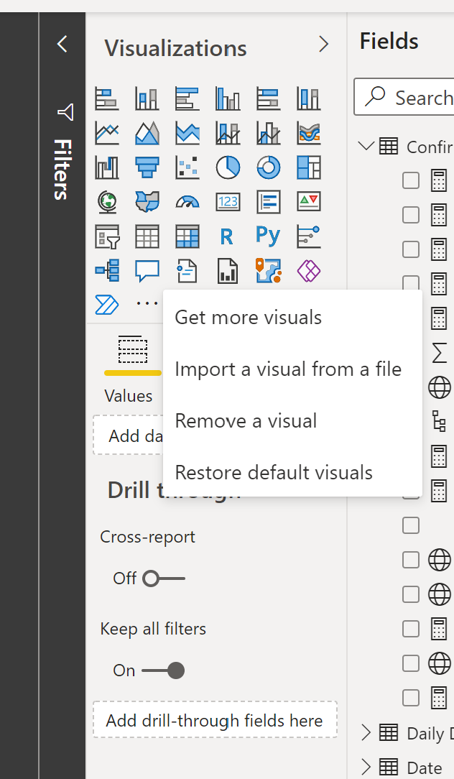
This takes you to the PBI Visuals app Store. We will need to download and install 1 custom visual, the word cloud. Search for each visual and then press ‘add’ to add them to your current report.
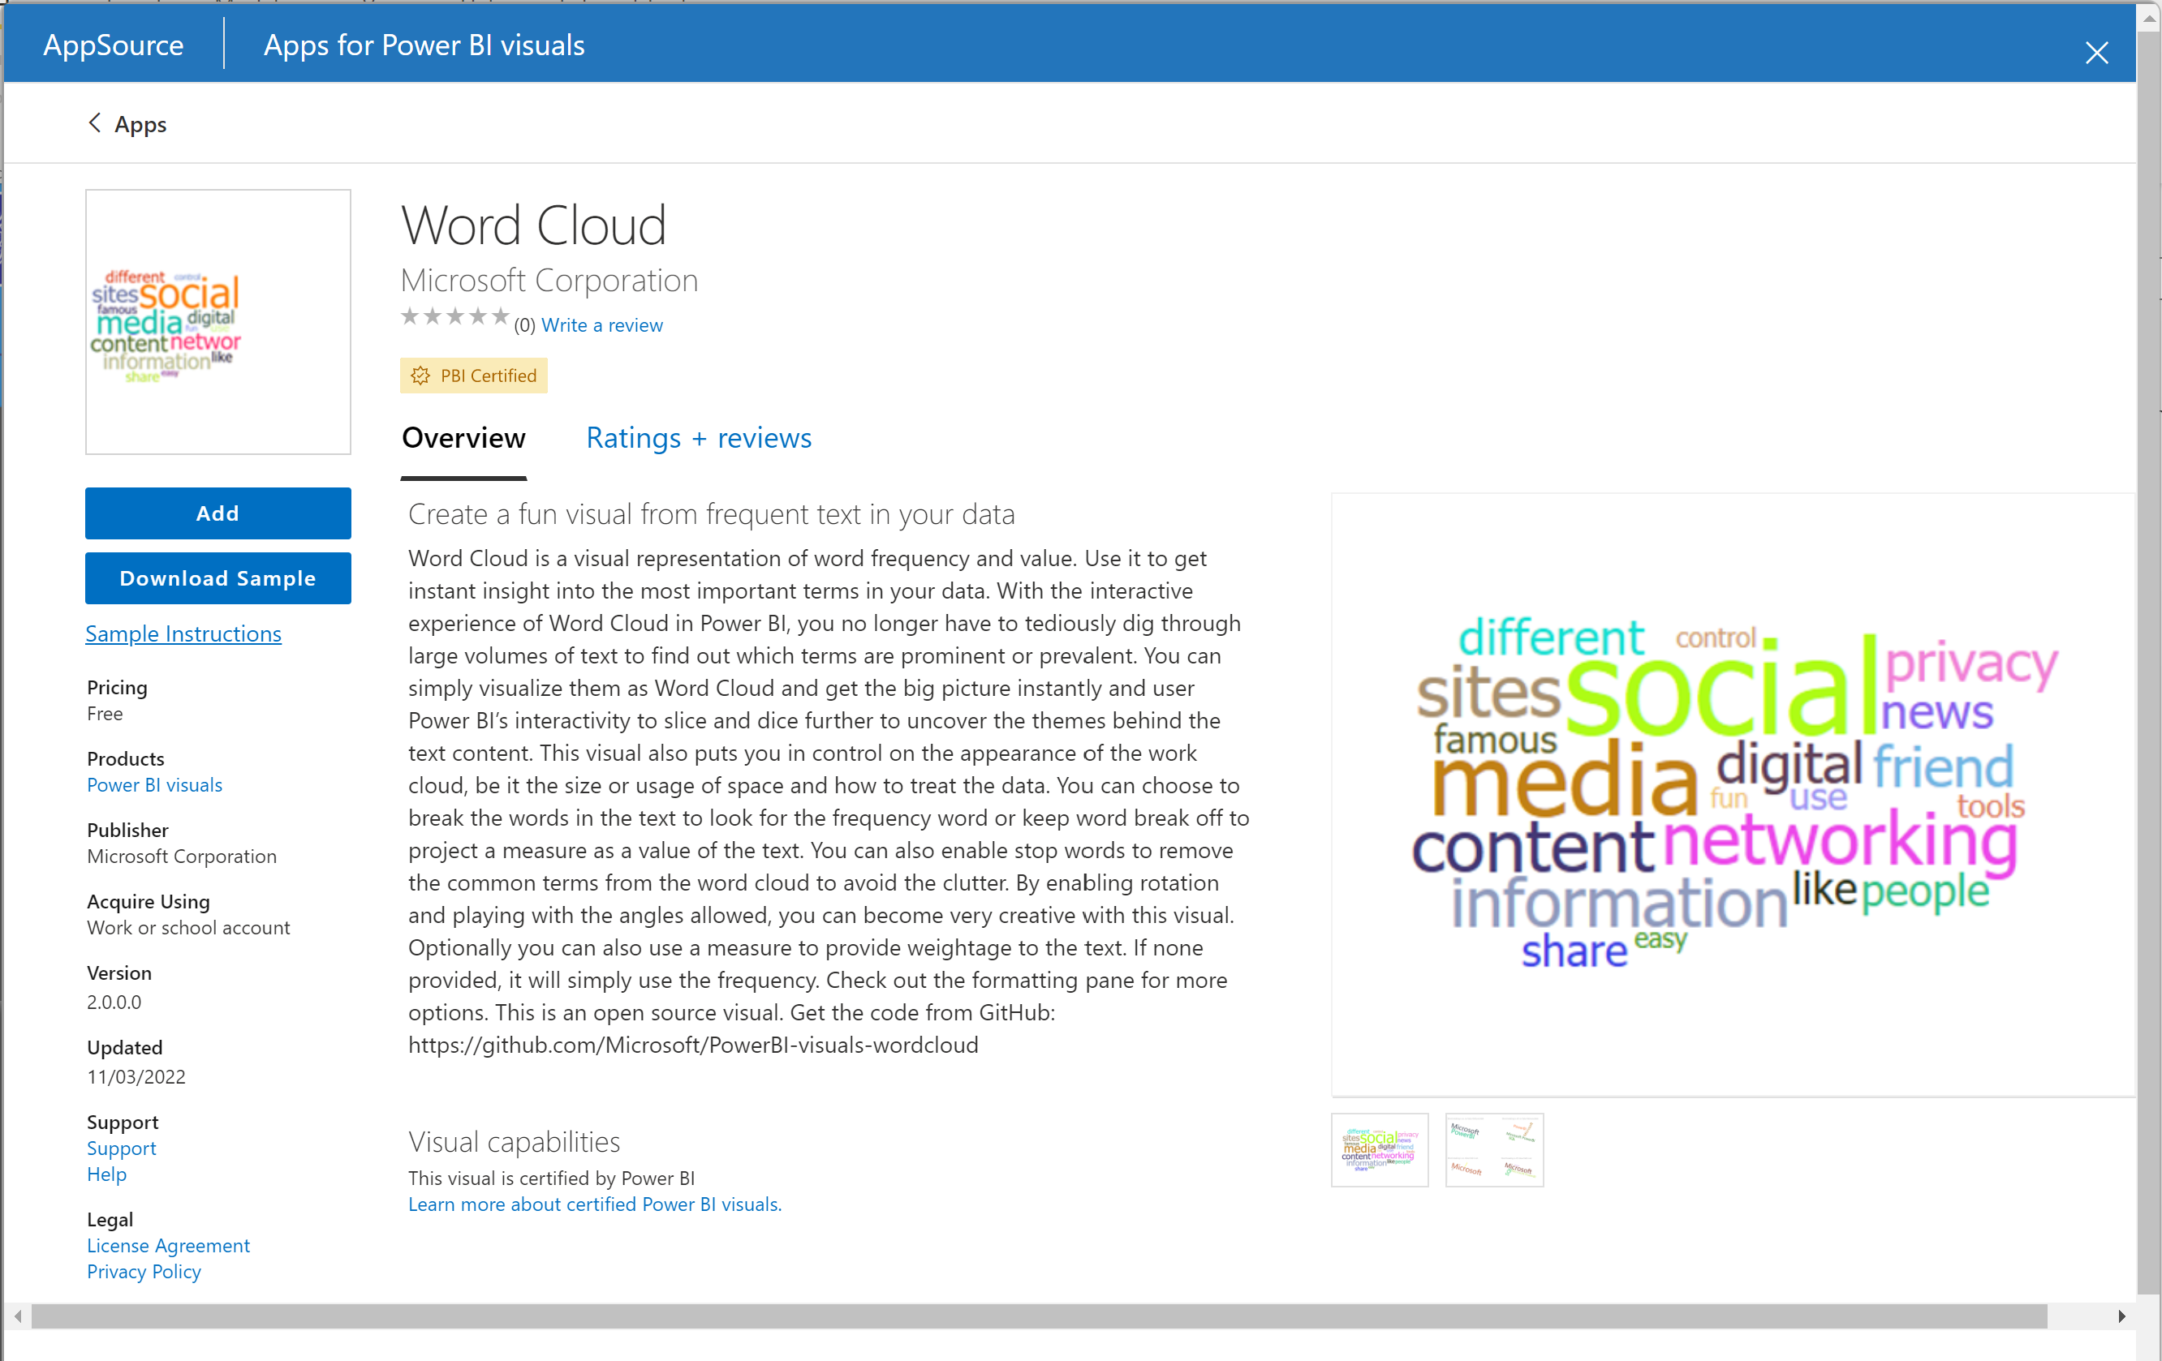
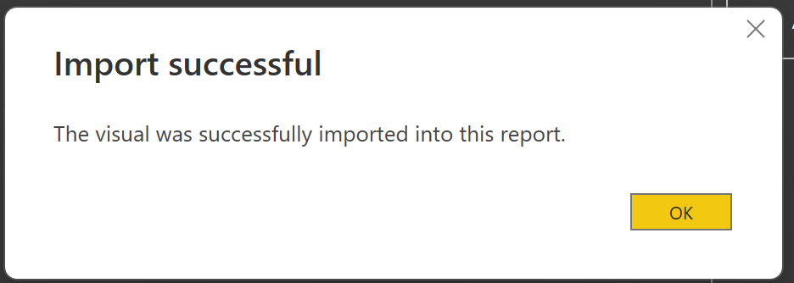
The visual should now appear like below:
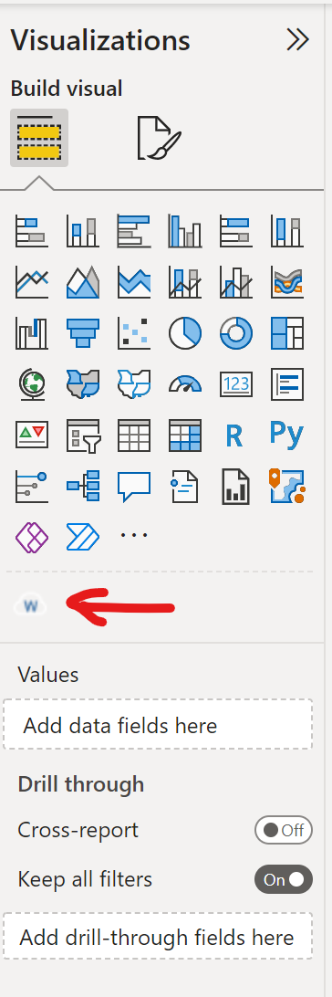

Page 1
- We will create the following cards to display at the top of our report:
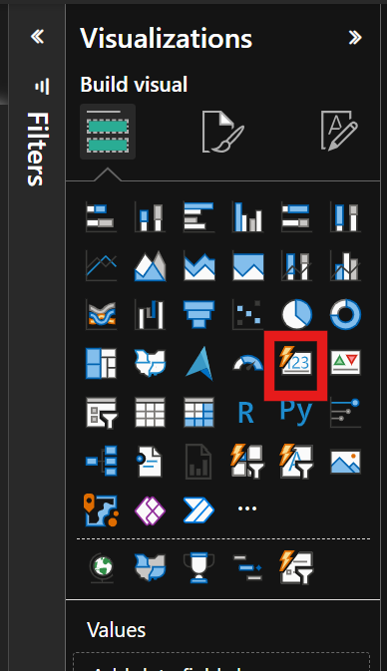
Drop and drag the following measures into your Card visual.
Total Crime Count – This is the measure from ‘Crime’ table
Crime Rate (Per 1000) – This is the measure from ‘Crime’ table
Total Crime (unfiltered) – This is the measure from ‘Crime’ table
% of Total Crime – This is the measure from the ‘Crime’ table.

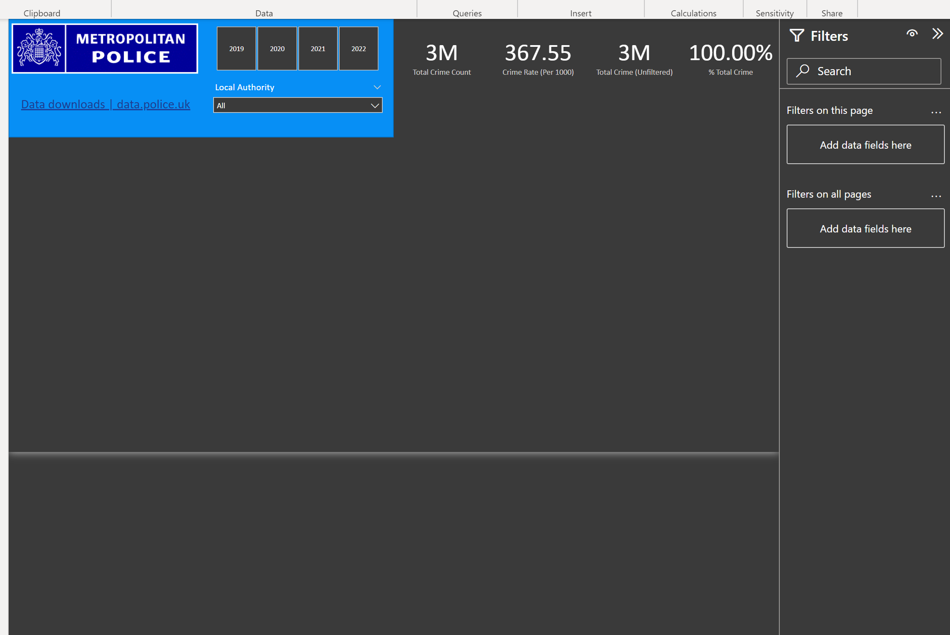

We shall now create a ‘Line and clustered Column Chart’ for Total Crime by Month and year. Drop and Drag the measure for ‘Total Crime’ onto your canvas followed by the ‘Month & Year’ column from the Data Table. Finally add the measure ’12 Month Rolling Average’ to Line Y Axis:
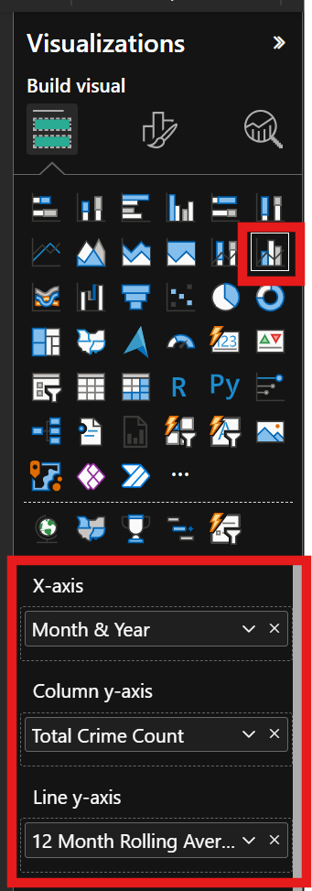
The visual should something like this:
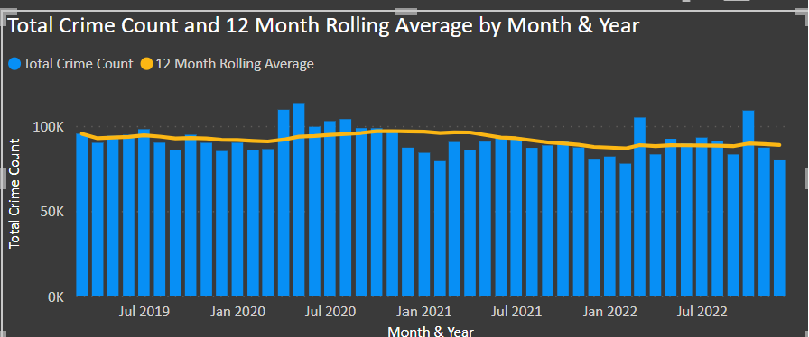
Please feel free to be creative with your formatting. It is the only way you will get better at report design!

- Next, create a visual for the Top 10 Crime Types. For this one, I use a tree map (but you can use a pie chart if you really want to!). To display only the top 10 crime types rather than all crime types, you can use the filter function:
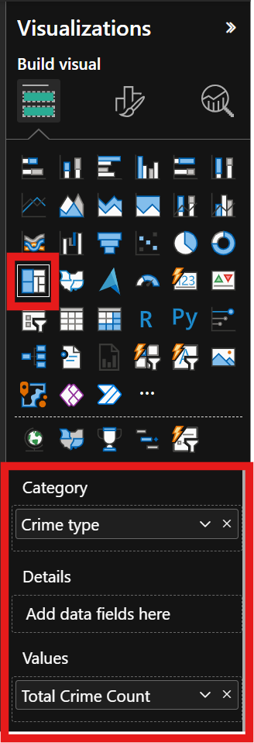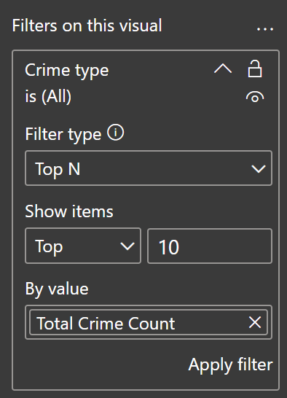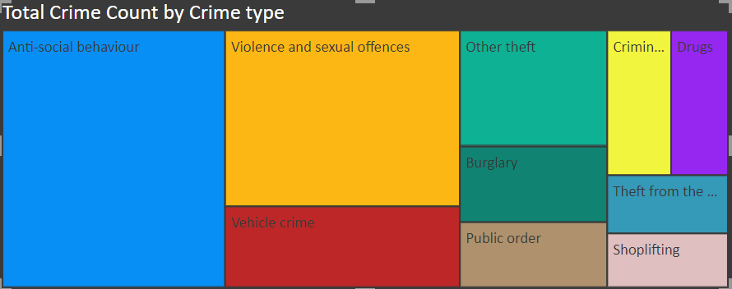
- Finally we will create a Map visual to display where the crimes have taken place. First Drop and Drag the Location hierarchy onto the blank space on the canvas.
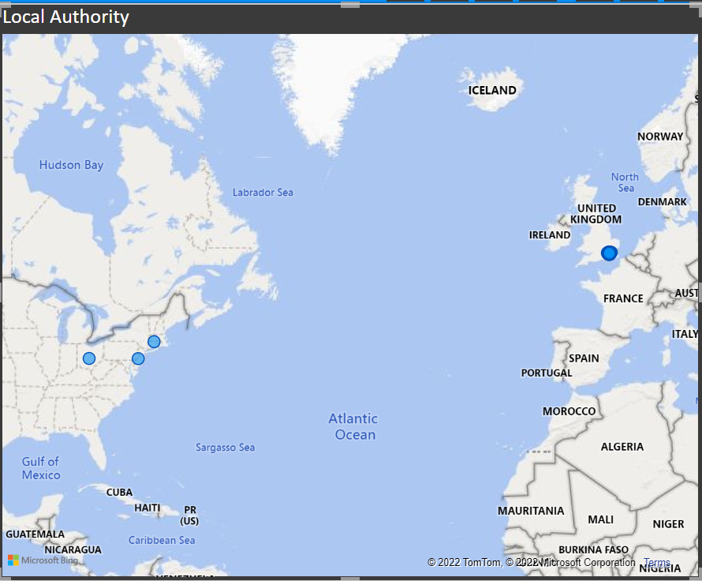

As you can see, the locations aren’t quite right yet but we can resolve this by dropping the lattitude and longtitude onto their respective data fields for the visual.
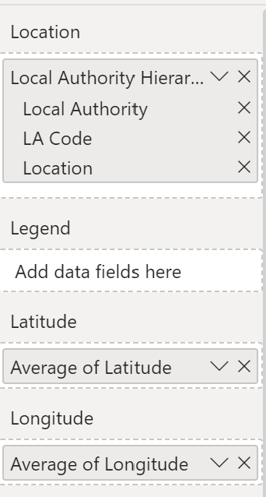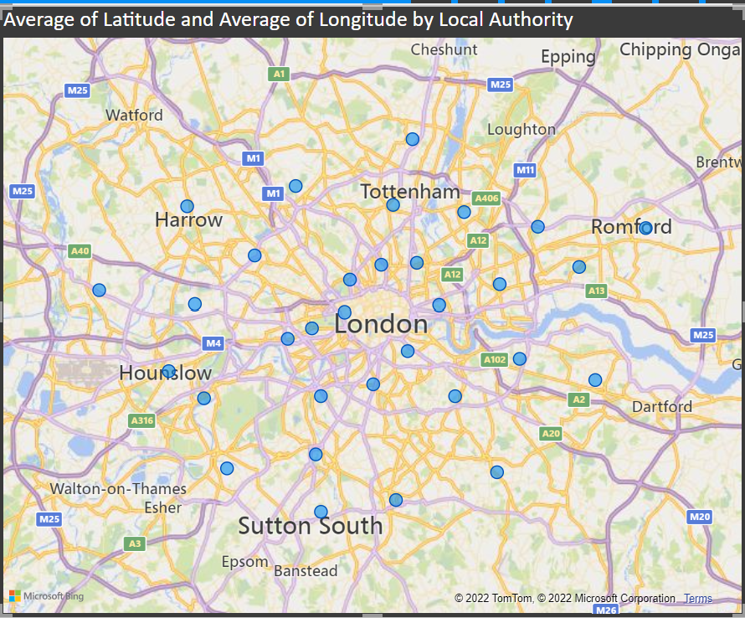

Finally, to display where the most crimes have taken place, add the ‘Total Crimes’ Measure to the Bubble Size data field:
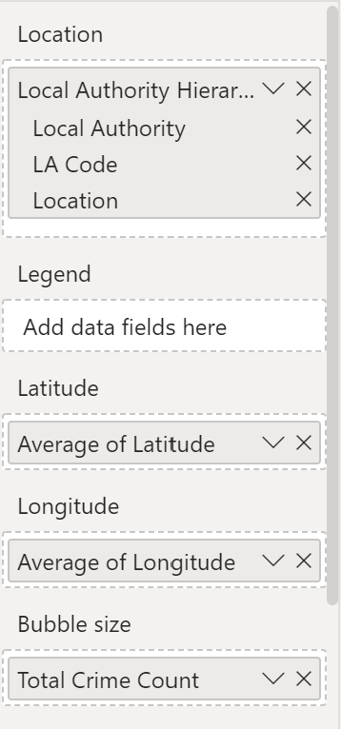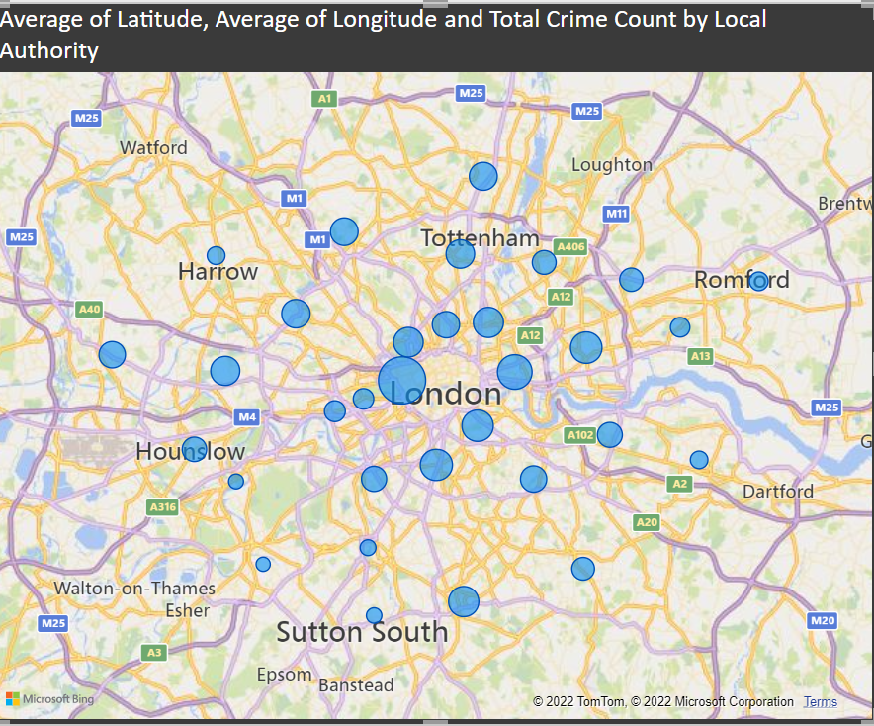

Because we have used our Hierarchy, we can now easily drill down into the data for on our map visual. To do this, click on the down arrow for your map visual.
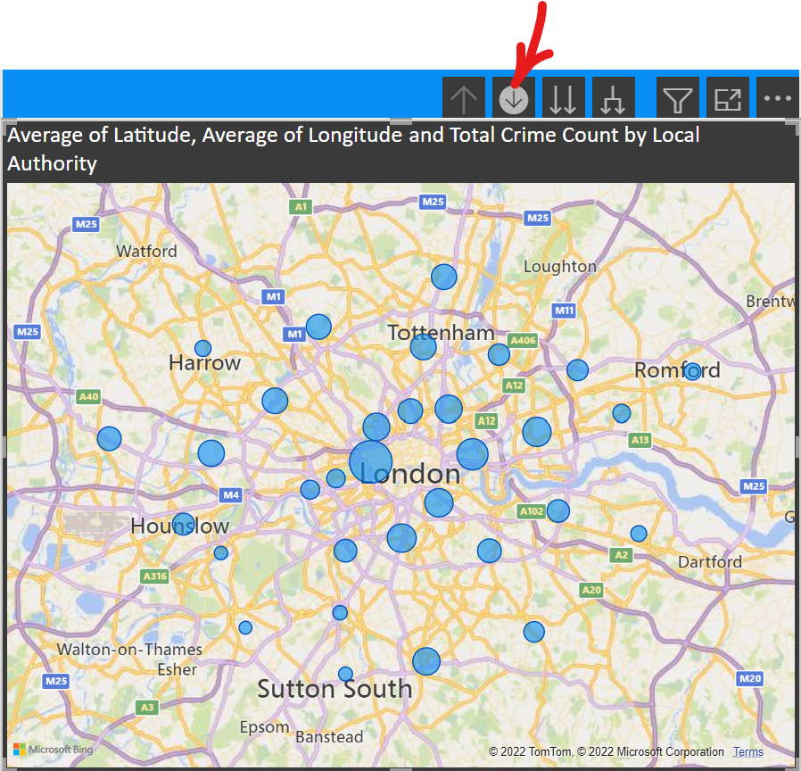
Now, when we click on any of the bubbles, the visual will zoom into this area to breakdown the crimes into the LA Code. If you click on a bubble again, you will see a breakdown of the crimes committed by their rough location so your report viewer can see at a low level, where the biggest concentration of crime is in a London Borough.
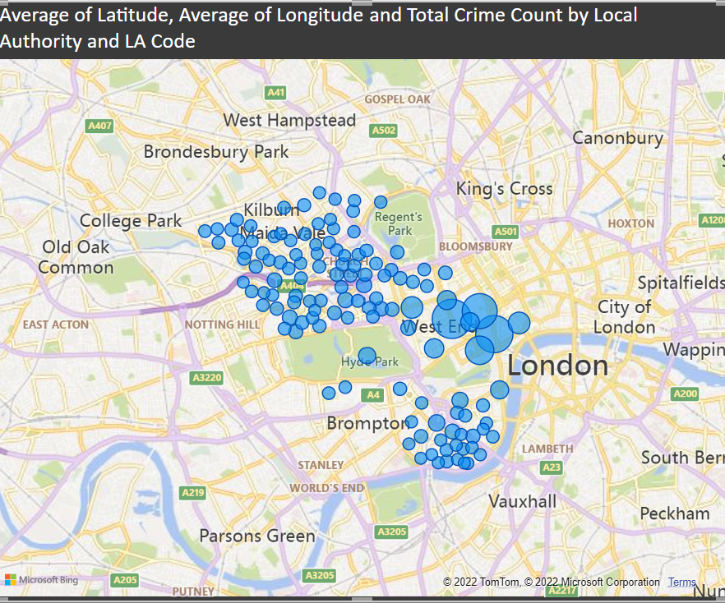
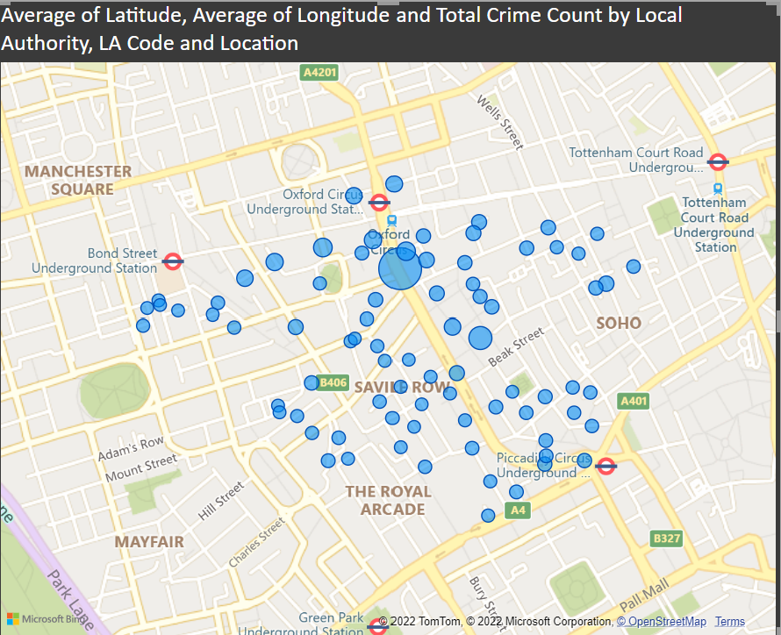
The final step is to clean up the title of the graph. I would suggest either turning it off (the visual should be self-explanatory) or making the title more digestible to the viewer.
Page 1 is now complete!

Page 2
- % of Crime by Type – Create a Funnel chart for Total Crime by Crime Type.
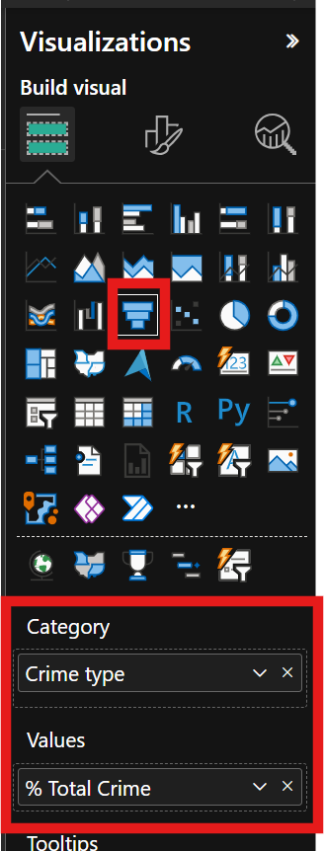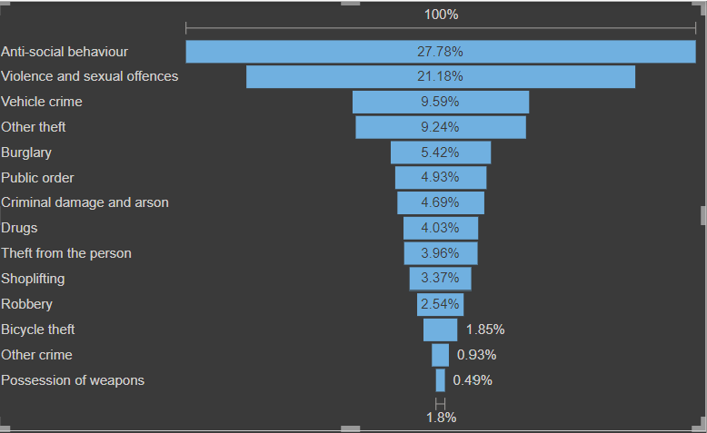

- Crime Rate by Month and Year – Create a Stacked Area chart with the Crime Rate Measure and Month and Year.
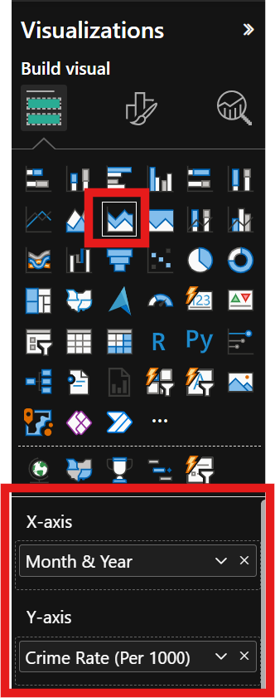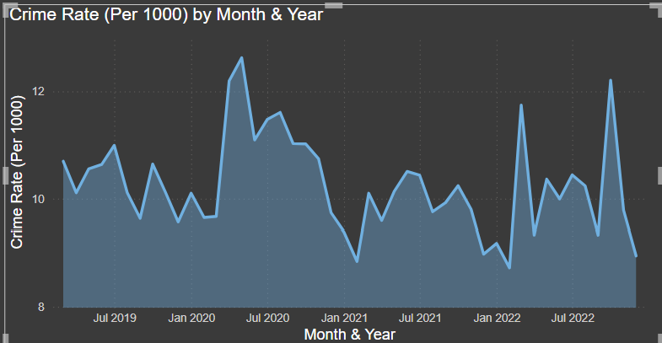

- Crime Rate (Per 1000) by Location. Create a Line and Clustered Column Chart. Add ‘Local Authority’ to the X Axis and Crime Rate (per 1000) to the Y axis. Add the ‘Population[Population]’ graph to the Line Y-axis field and make sure it displays the aggregation ‘SUM’ (this is so it only shows the very latest value for population rather than summing it all up). You may also want to restrict this chart to show only the Top 10 Local Authorities.
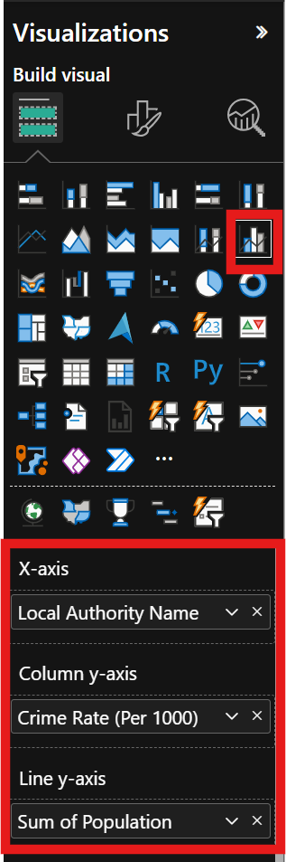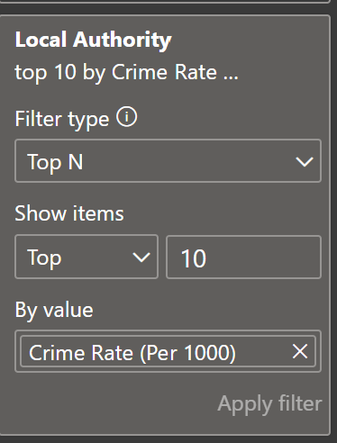

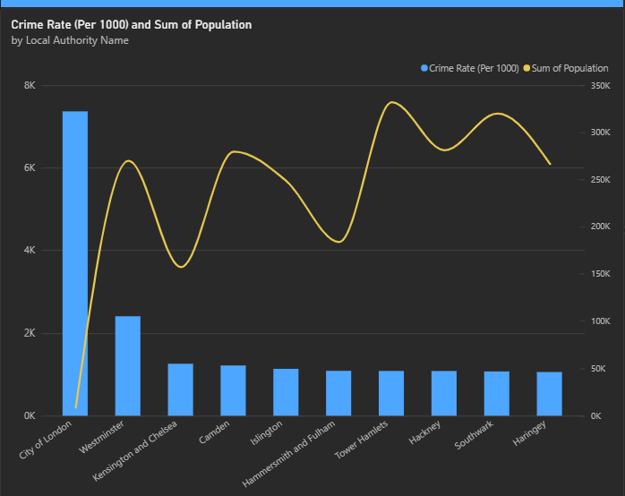
Let’s also stop this visual from interacting with the Local Authority Slicer as it becomes much less interesting when it is filtered by this:
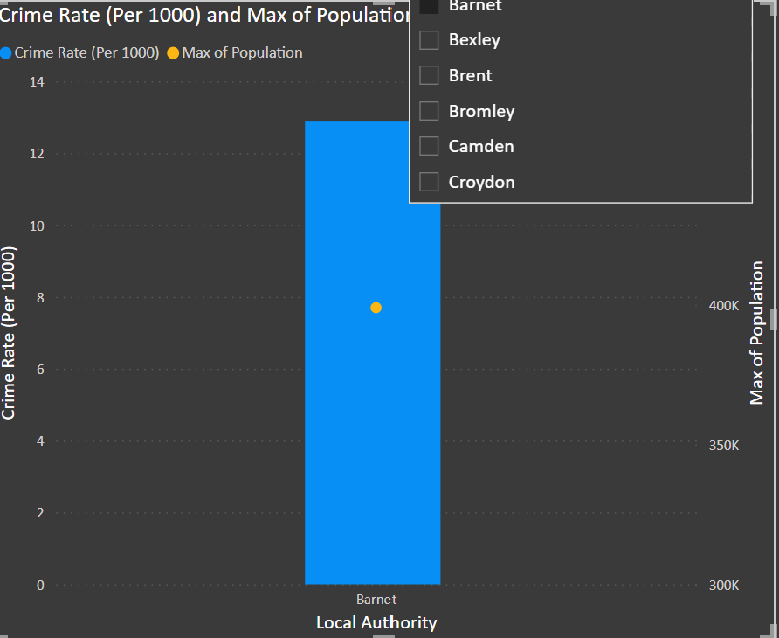
To do this. Highlight the slicers and click on the ‘edit interactions’ button.
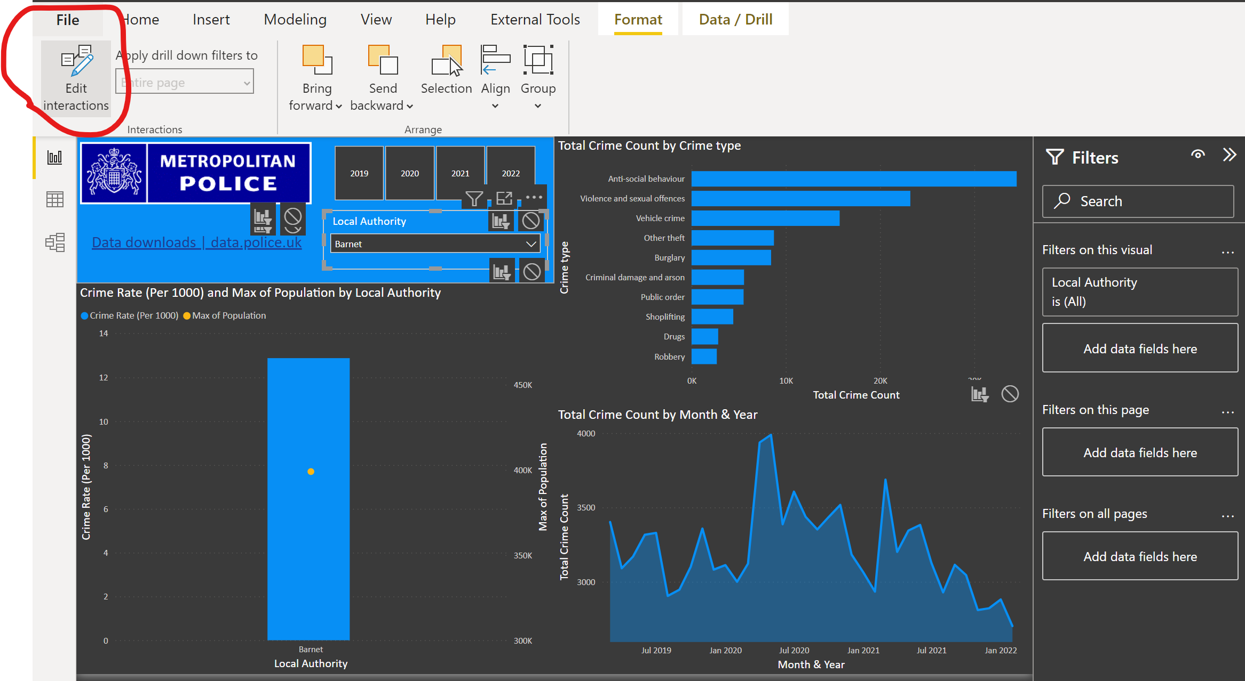

Now click on the ‘Stop’ sign next to your visual to stop it interacting. You should automatically see the visual return to it’s original state.
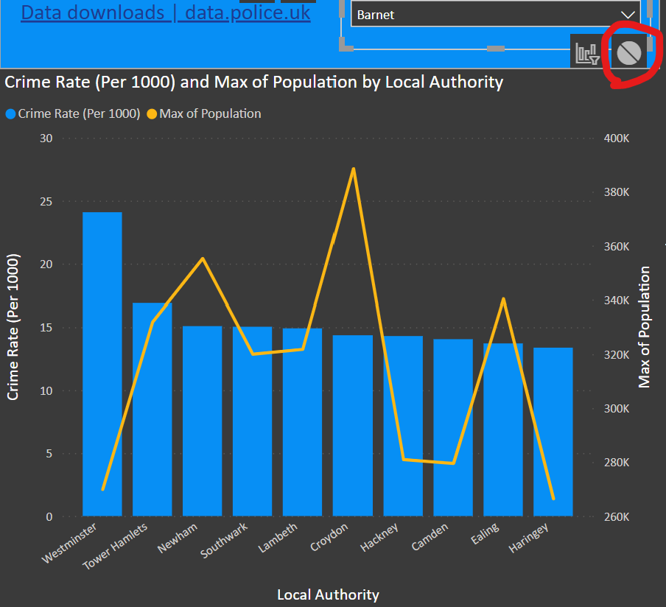

- Finally Clean up the titles or remove them (if the subject matter is self-explanatory) and then save your report.
Page 2 is now complete!

Create Drill-Through Page
With drill-through in Power BI reports, you can create a destination target page in your report that focuses on a specific entity such as a supplier, customer, or manufacturer. When your report readers right-click a data point in other source report pages, they drill through to the target page to get details that are filtered to that context. You can set up drill-through in your reports in Power BI Desktop or the Power BI service.
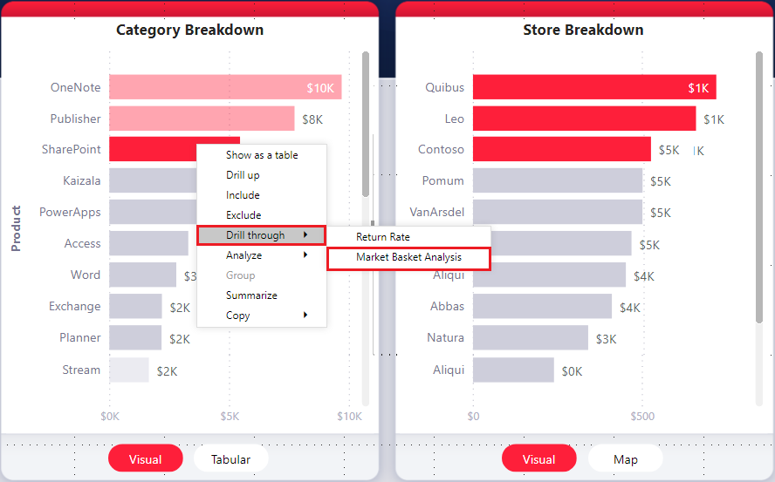

- Create New page and call it ‘LA DrillThrough’. Then right-hand click on the tab and select ‘hide page’. This will hide the page from general report navigation so the only way to access it is via one of the main page visuals.
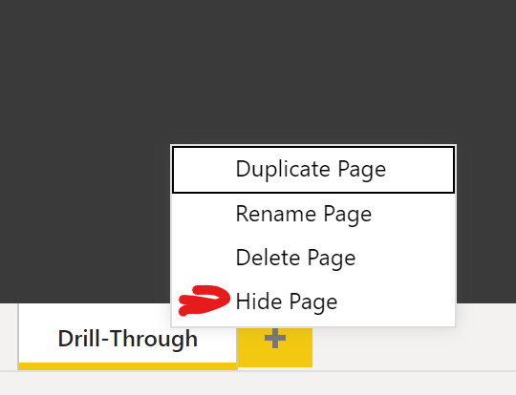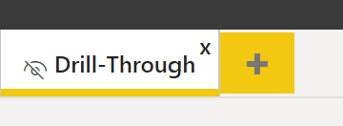
- Then, on that drill-through target page, in the Fields section of the Visualizations pane, drag the fields ‘Local Authority’ and ‘LSOA Code’ for which you want to enable drill-through into the Drill-through filters well.
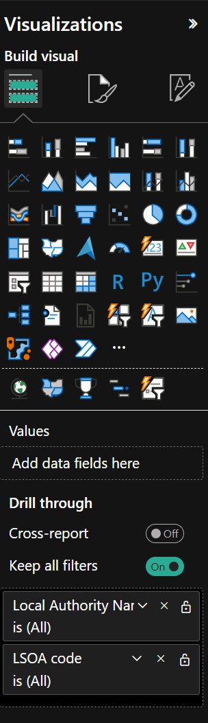
When you add a field to the Drill-through filters well, Power BI automatically creates a back button visual. That visual becomes a button in published reports. Users who view your report in the Power BI service use this button on the target page to get back to the original source report page from which they came. Resize the button so it is more visible.
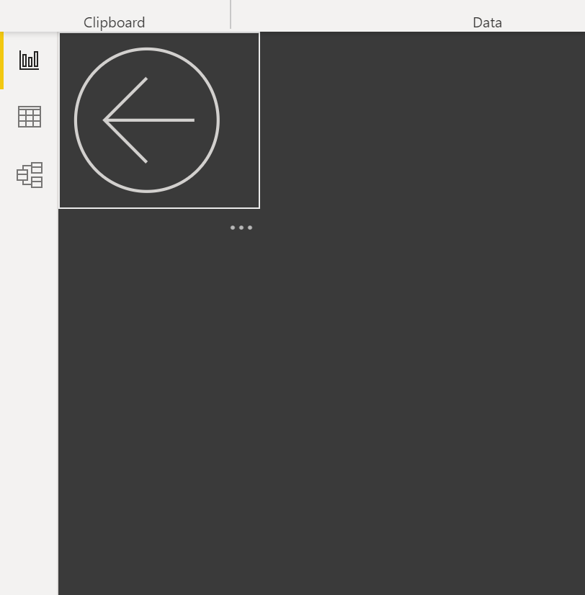

- Cards – We will a card visual to the top of this report page. The first one is for the ‘Local Authority Name’ and make sure the aggregation is set to ‘first’. Remove the category label too.
- 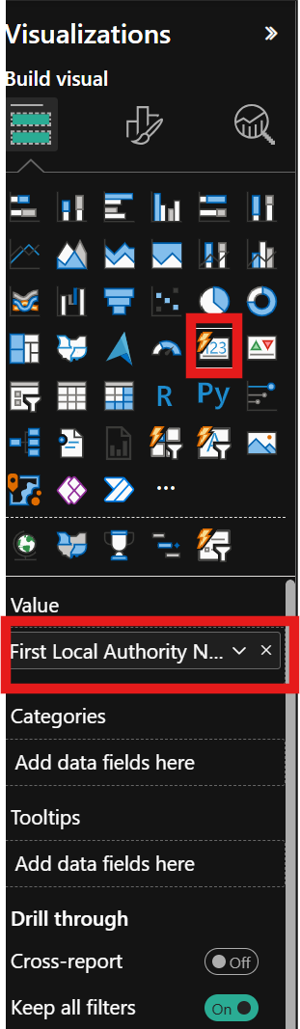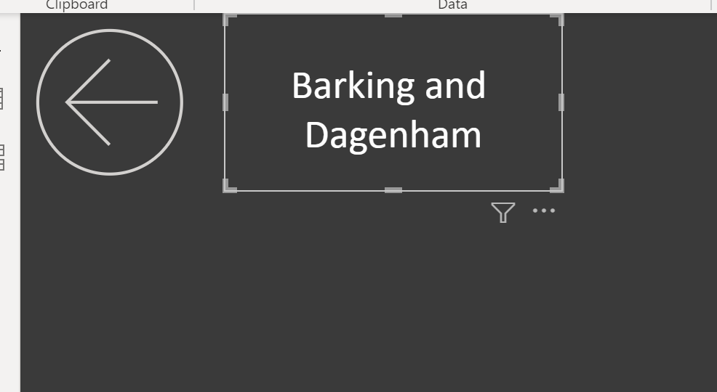
Now add 4 more measures in this card:
- Population[Population] (set agregation to ‘Sum’)
- Crime[Total Crime Count]
- Crime[Crime Rate (per 1000)]
- Crime[% of Crime]
- Finally format the card similar to below. (I have removed the label for the Local Authority Name)
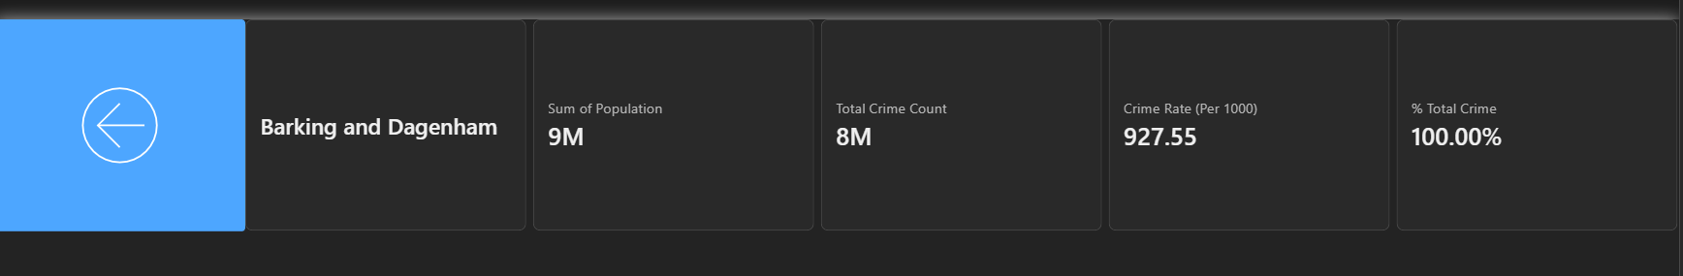
- Now will add a new Map visual. Drop the ‘Local Authority’ hierarchy on the map and remove ‘Local Authority’ from the top of the hierarchy. Also add ‘Latitude’ and ‘Longitude to their respective fields:
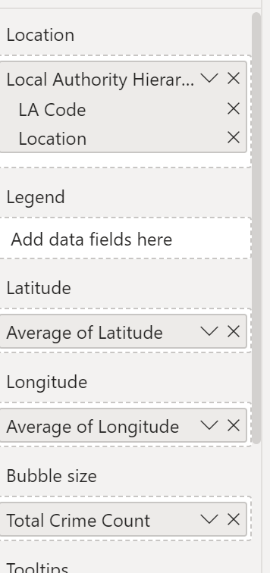
Finally Remove the Title for the map and place it on the left hand side of your page:
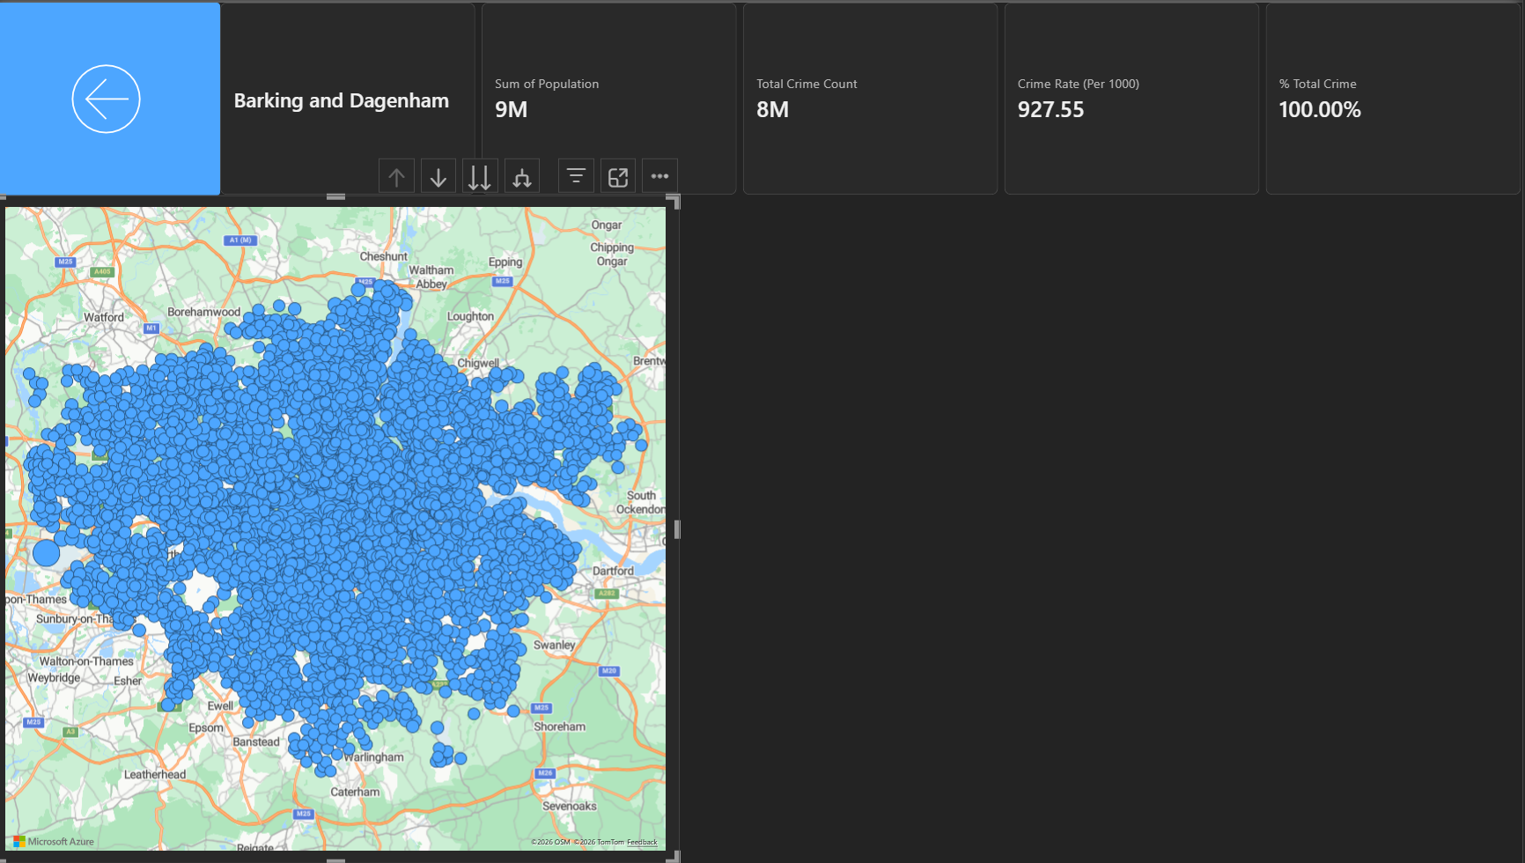
Don’t worry if you think it looks like a mess and makes no sense! – It will do when you interact with this page later.
- Create a Funnel Visual for Crime Type and Total Crime Count.
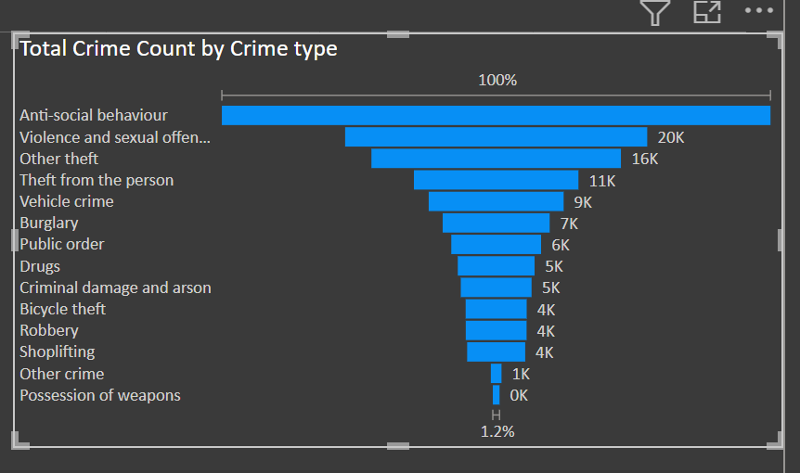
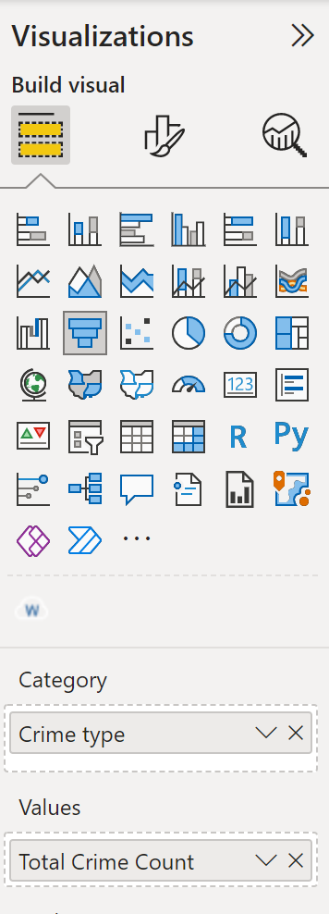

- Add a new Line and Clustered Column Chart for Total Crime Count for Month and Year. Add the Crime Rate (per 1000) as the Line Y-Axis value:
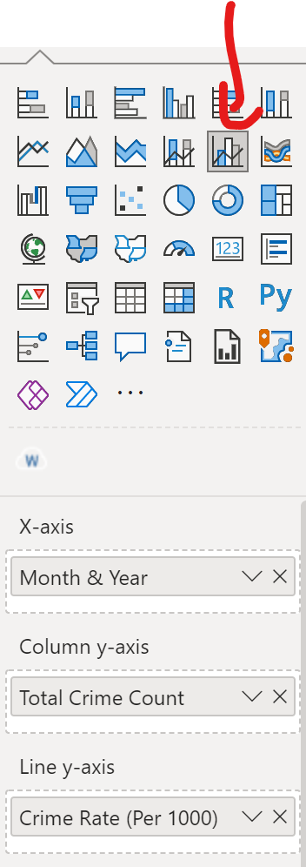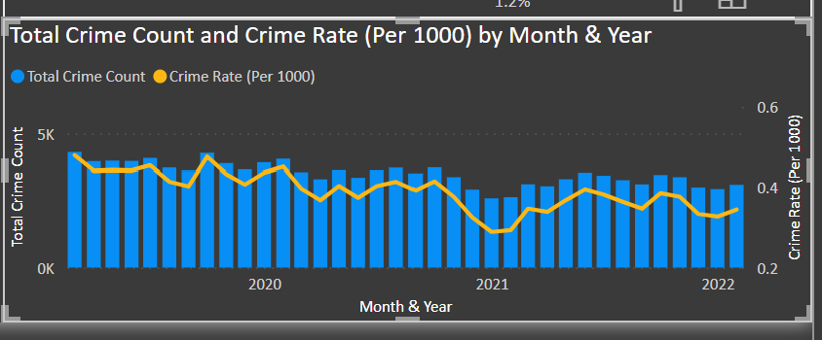

- Finally format your visuals and report page to your preference:
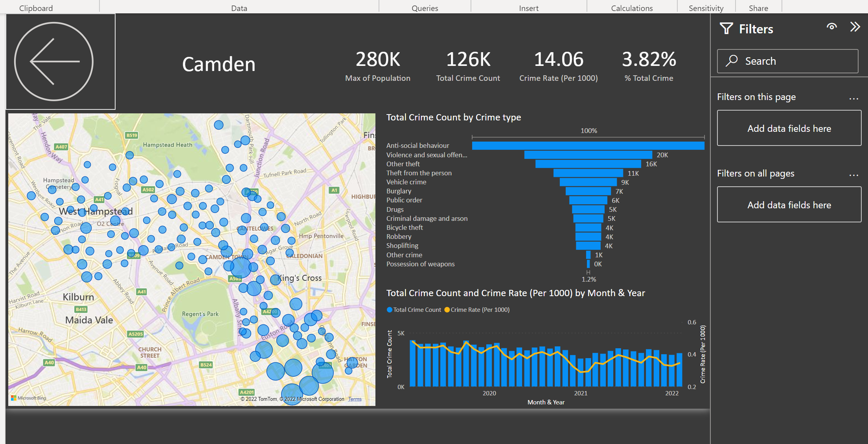

Your drill-through report is now complete!
Test to make sure it works by going to page 1 and right clicking on a bubble from your map visual and select ‘Drill-Through’.
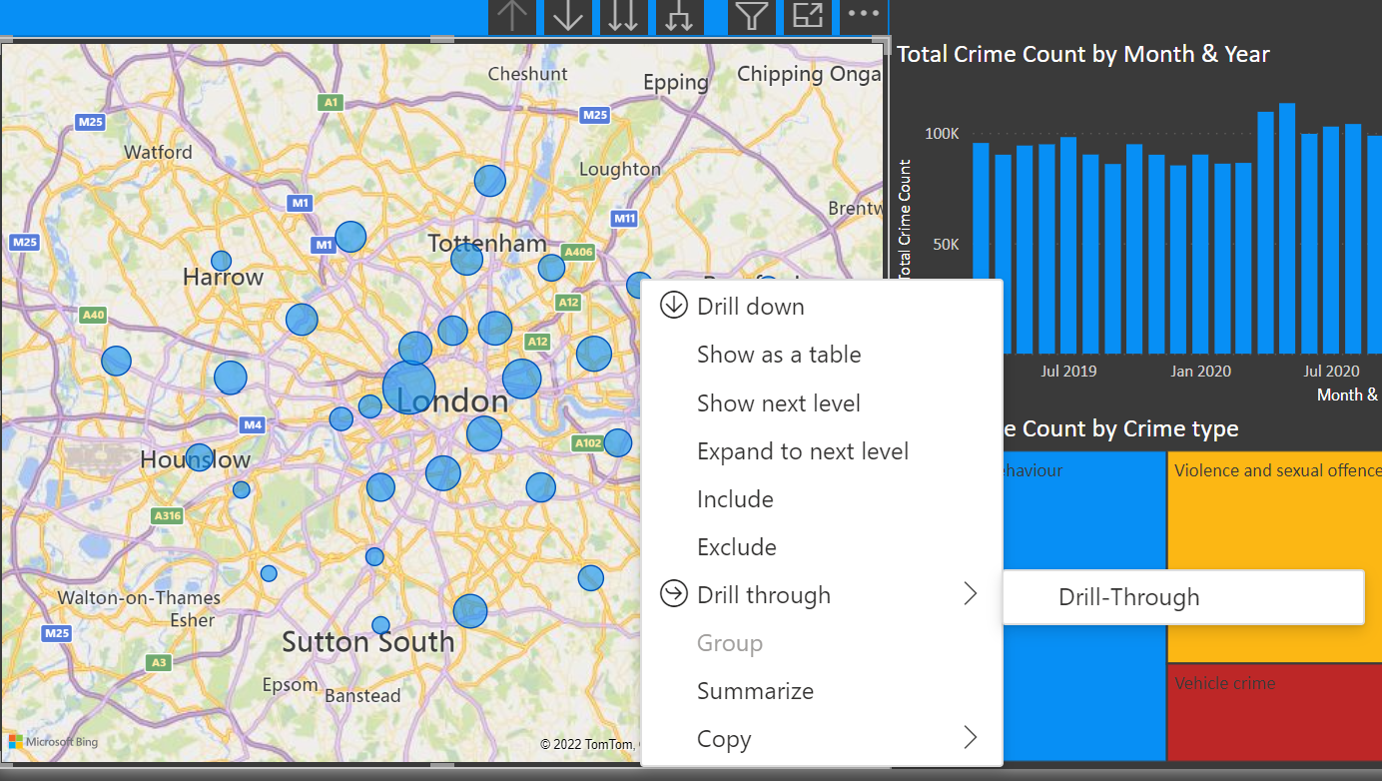
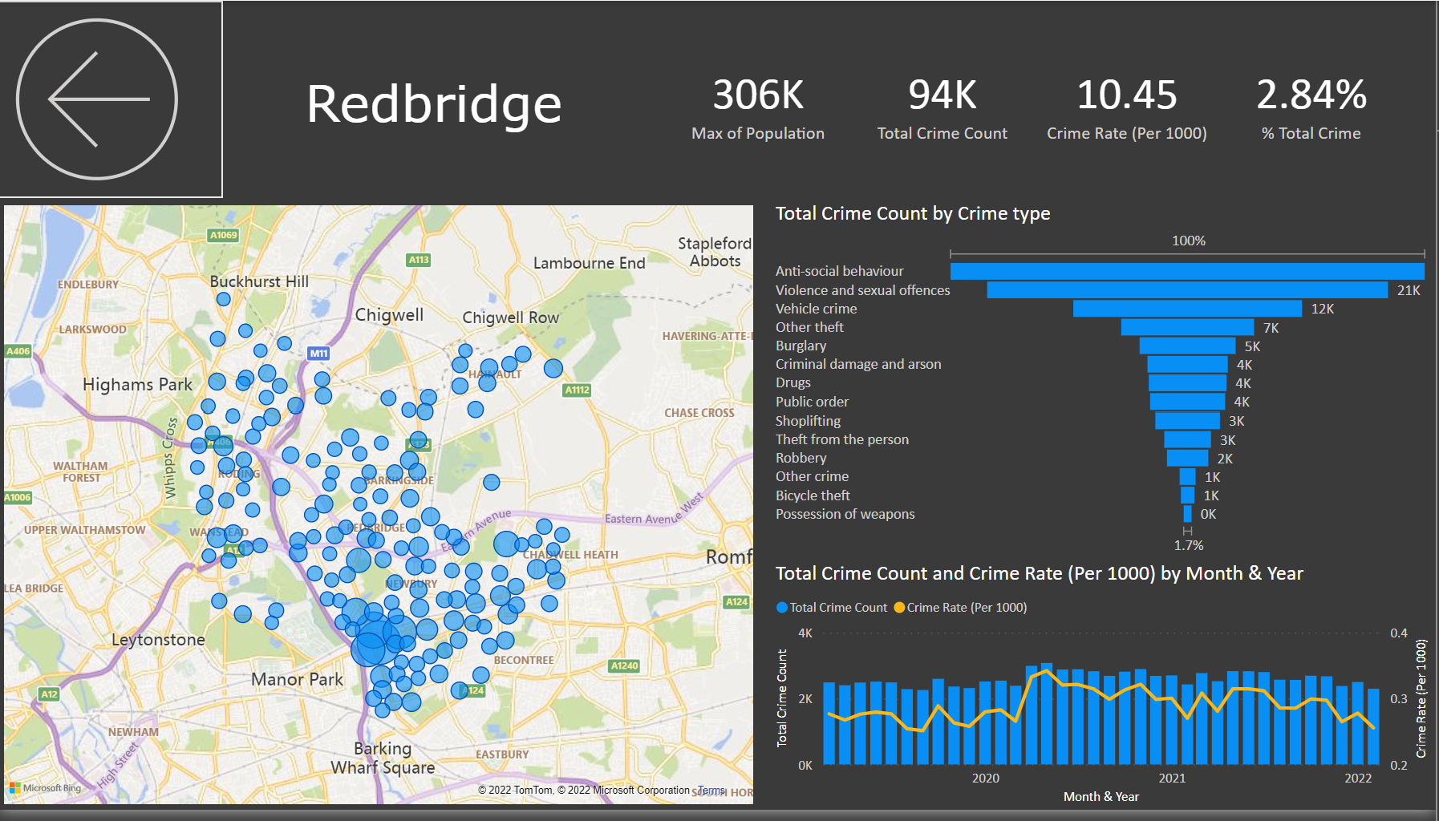

Create a Tooltip
You can create visually rich report tooltips that appear when you hover over visuals, based on report pages you create in Power BI Desktop. By creating a report page that serves as your tooltip, your custom tooltips can include visuals, images, and any other collection of items you create in the report page.
For more information, please visit https://docs.microsoft.com/en-us/power-bi/create-reports/desktop-tooltips
- First lets create a table visual on a new page with some basic information in. This table displays countries with count of customers, count of sales and Net Profit:

- Now create a new page and call it ‘Tooltip’ and ‘hide’ the page (as you did with the drill-through page’.
- In the format pane for the page, make sure that ‘Allow use as tooltip’ is enabled:
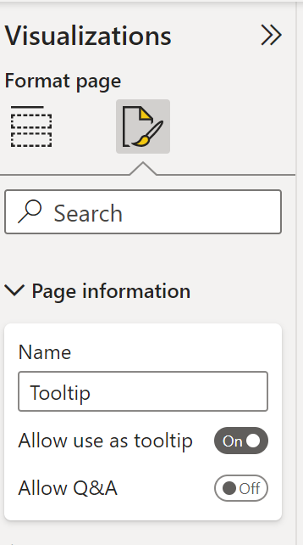

- Next in the view tab at the top, select ‘Page View’ > ‘Actual Size’. Your report page should now look like this:
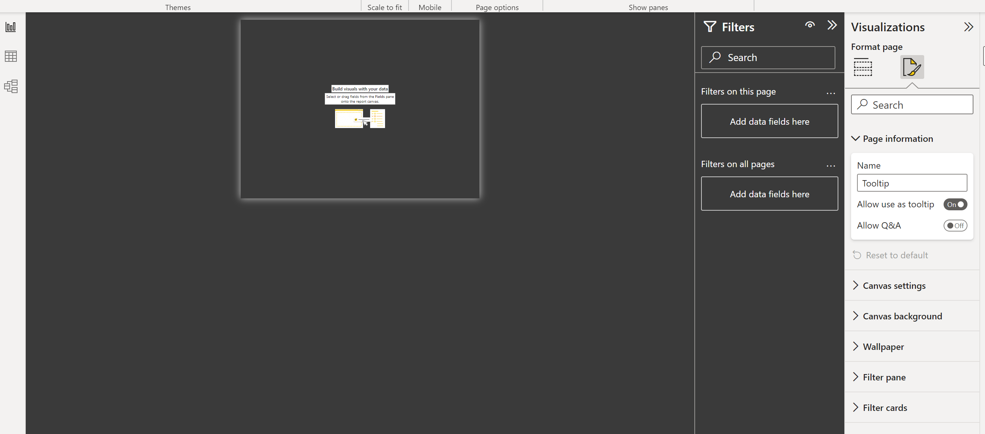

- Now we can create some visuals on the canvas.
I created two cards. One for total Crime and another for % of crime. I then added a line chart to display total crime for month and year and a clustered column chart to display the % Total Crime for month and year. You could also add the name of the Local Authority (use the same method as you did in the drill-through). Again, it is important not to worry about the values at this point as it will only display the correct values when you are interacting with your report.
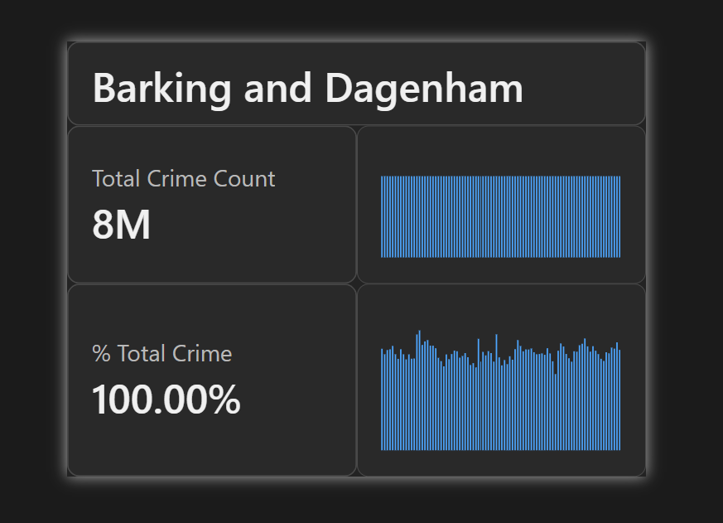

- Now go to page 1 and in the format pane for the map visual, switch on the Tooltip option and then select the page as ‘Tooltip’.
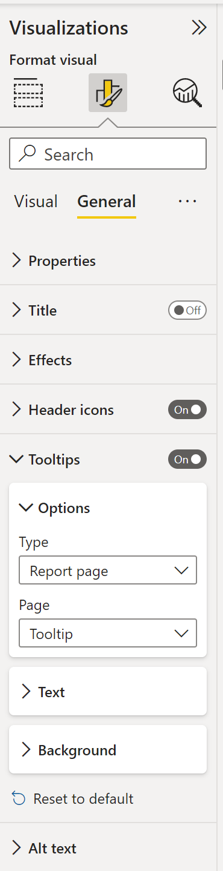
- Now hover over your map bubbles with your mouse and you should see the Tooltip page appear.
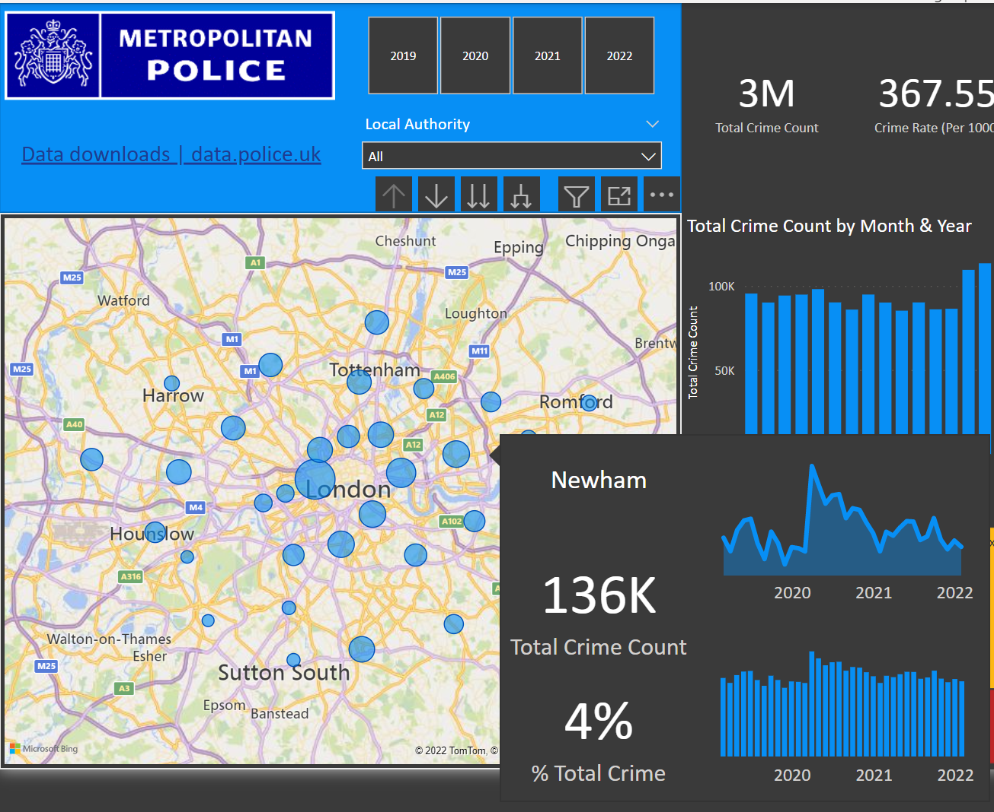
Your tooltip page is now complete!

Row Level Security
For the final part of your report, we will demonstrate row level security.
What it is
- Row-level security (RLS) controls which rows of data a user can see in a Power BI semantic model. Everyone uses the same report and model, but each user sees only the data they're allowed to see, such as their own region, business unit or customers. Power BI applies the filter at query time, so it covers every report, dashboard and visual built on that model.
How it works
- Roles: You create security roles in the semantic model, either in Power BI Desktop or in the Power BI service.
- DAX filter expressions: Each role has one or more DAX expressions on tables, such as [Region] = "North". When a user in that role runs a query, only rows where the expression is true come back.
- Filter propagation: Filters spread through the model's relationships. If you filter a dimension table, the related fact tables are filtered too. You can let a security filter travel both ways across a relationship by turning on "Apply security filter in both directions", but use this carefully.
- Role membership: After you publish, you add users or, preferably, security groups to each role in the semantic model's Security settings in the Power BI service.
This is a quick demonstration on how we can restrict data based on your security role and we are going to do it using Local Authorities.
On the modelling ribbon, click on ‘Manage Roles’
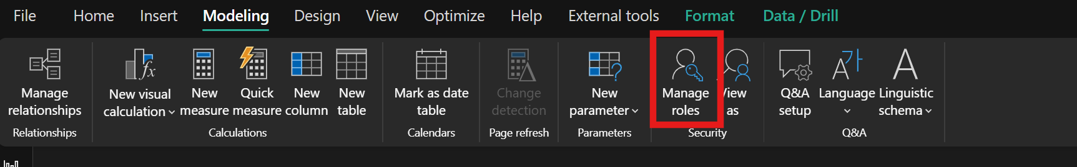
In the frame that opens, click on ‘new role’. right-click the role and call it ‘Lambeth’.
Highlight the ‘Crime’ table and click on ‘New Rule’. Change the column to ‘Local Authority’. The condition should be ‘equals’ and the value should be ‘Lambeth’.
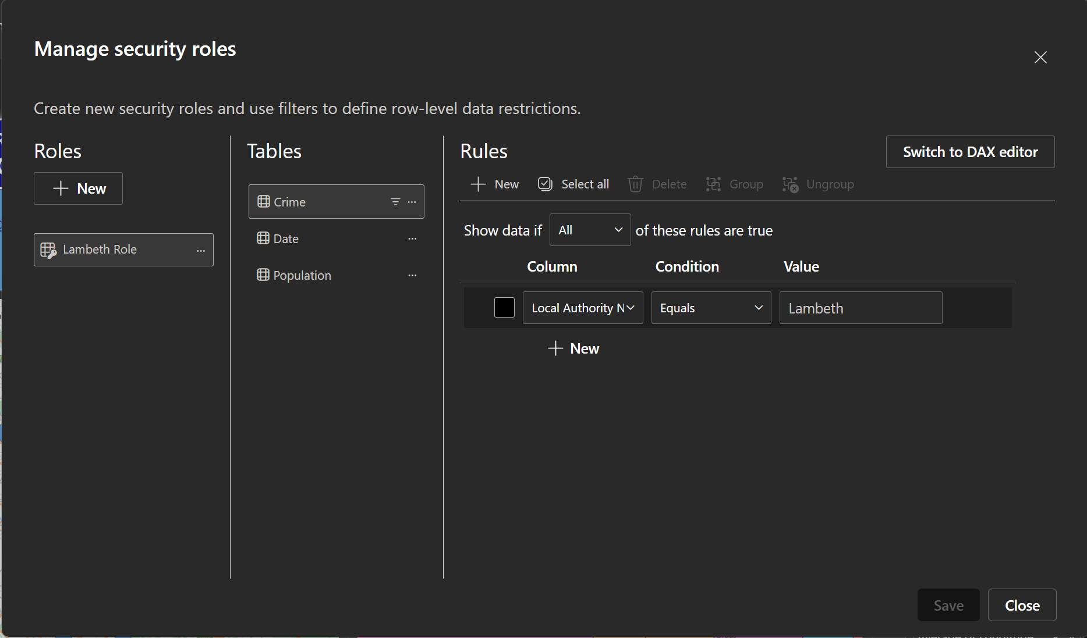

Now repeat this step for several local authorities. Make sure the value is equal to the actual local authority name:
Camden
Westminster
Hackney
Tower Hamlets

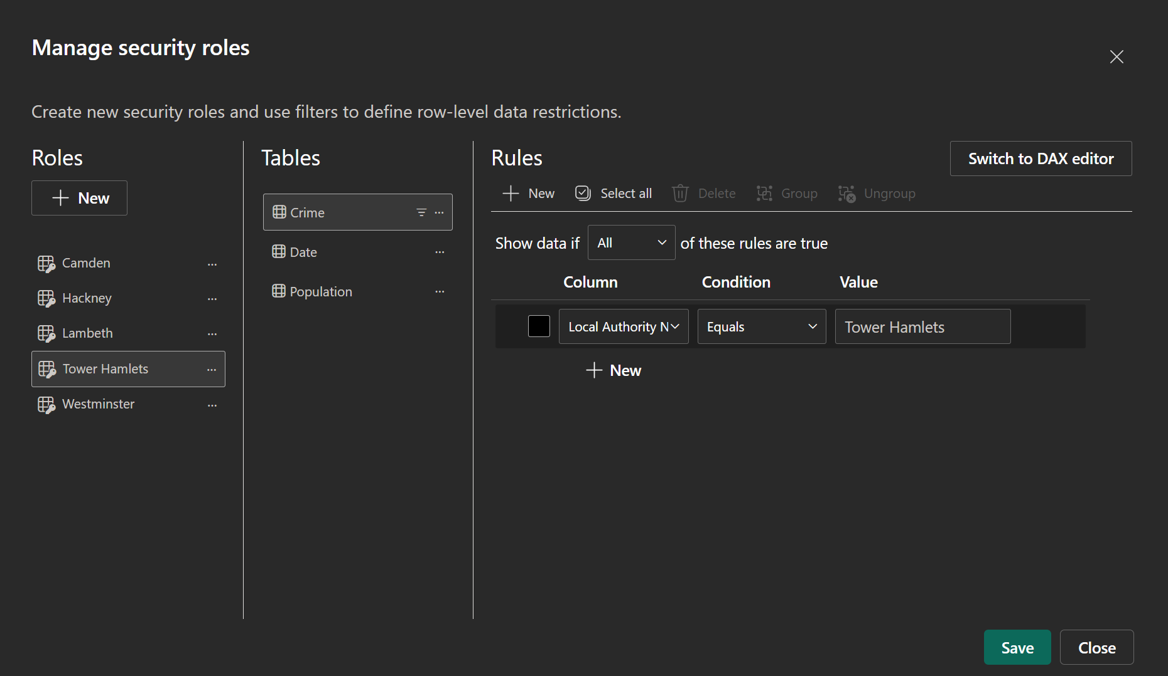
Once you have created several roles, click on ‘save’ and return to your report.
To test the roles click on ‘view as’ in the modelling ribbon:
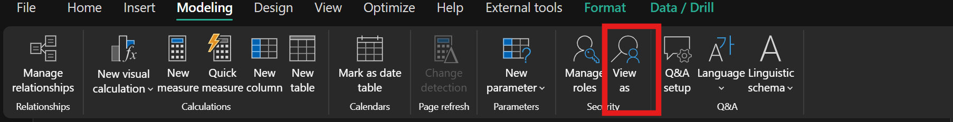
Now try out the different roles. When you choose a different role, the data in your report will be filtered to that specific local authority:
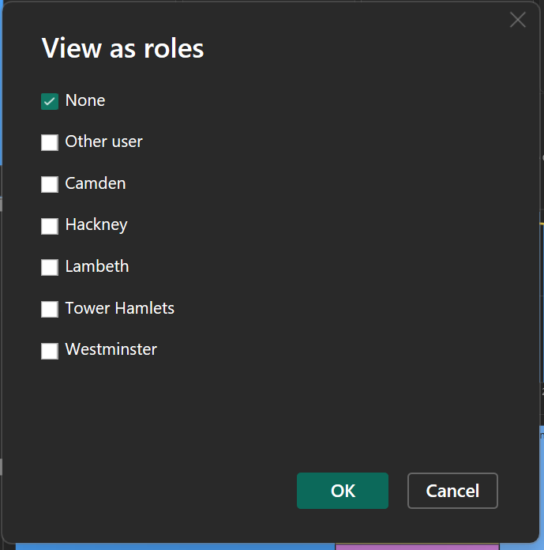

Thoughts about Extending Your Model
Sometimes the problem with creating a good report that tells a story, is that creates more questions, and the story can (and should) get bigger. Firstly, there is probably several more visuals you could make with the data that is already in the model.
There could also be a number of ways in which we could extend this data model to be more informative. I have listed out some ideas below.
- Population Density
- Health
- Occupations
- Police Force Numbers and Effective strength of law enforcement agencies.
- Transportation
- Economic conditions, including median income, poverty level, and job availability.
- Cultural factors and educational, recreational, and religious characteristics.
- Policies of other components of the criminal justice system (i.e., prosecutorial, judicial, correctional, and probational).
- Attitudes toward crime.
- Crime reporting practices of the population
A lot of this data is open source and there are a number of ways you can collect this. I have listed out some website for you to start exploring:
Open data | data.police.uk
London Datastore – Greater London Authority
Search Results - data.gov.uk
Our open data - Transport for London (tfl.gov.uk)

Q & A Visualization (Power BI Service Only!)
The Q&A visual allows users to ask natural language questions and get answers in the form of a visual.
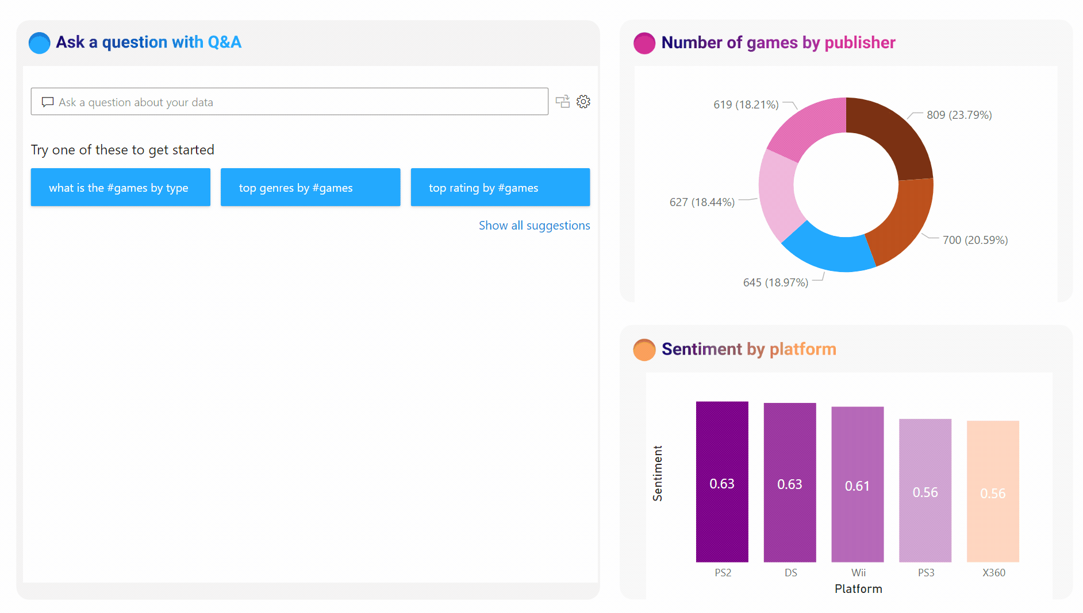
- Create a New Page and call it ‘Q&A’
- To add the Q & A Visual to a page, select the following visualization.
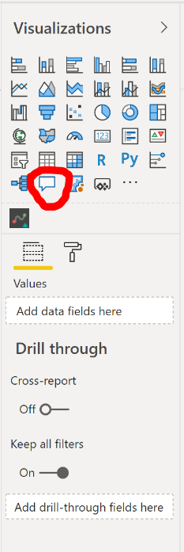

- Try typing in a question from one of the examples displayed or from one below:
- top crime local authority by % total crime
- what is the total crime count for Westminster (crime local authority)
- what is the total crime count crime type
- top 5 local authority by total crime count for Burglary clustered column chart
- Hackney total crime count for 2019
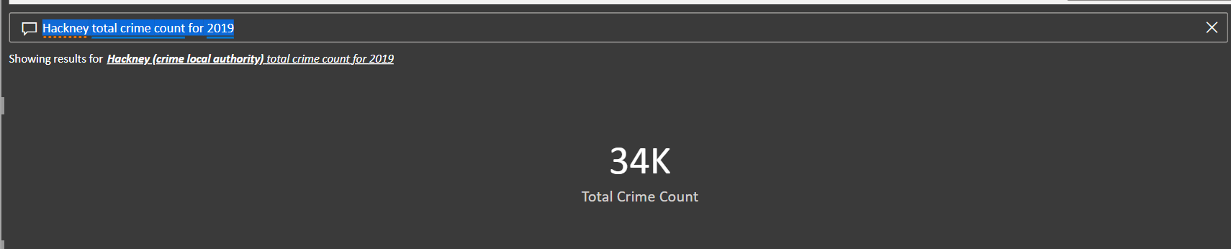

For more information on Natural Language Q&A, then please visit the following page: https://docs.microsoft.com/en-us/power-bi/natural-language/q-and-a-intro

Create a Workspace for your Report
A Power BI Workspace is a location in the Power BI service where you can share and collaborate on reports and datasets. We are going to make one for this report.
- Log into http://PowerBI.com
- In the left navigation bar, select ‘Workspace’>’Create Workspace’
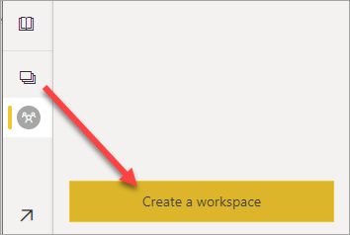
- Give the workspace a unique name. If the name isn't available, edit it to come up with a name that's unique.

- When you create an app from the workspace, by default it will have the same name and icon as the workspace. You can change both when you create the app.

- Here are some optional settings for your workspace. They're explained in more detail in the Workspace settings section later in this article:

- Upload a Workspace image. Files can be .png or .jpg format. File size has to be less than 45 KB.
- Specify a Workspace OneDrive to use a Microsoft 365 Group file storage location (provided by SharePoint).
- Add a Contact list, the names of people to contact for information about the workspace. By default, the workspace admins are the contacts.
- Allow contributors to update the app for the workspace
- Assign the workspace to a Premium capacity.
- Connect the workspace to an Azure Data Lake Gen2 storage account (in preview). Read about this functionality in the article Configuring dataflow storage to use Azure Data Lake Gen 2.

- Select Save.

Power BI creates the workspace and opens it. You see it in the list of workspaces you’re a member of.

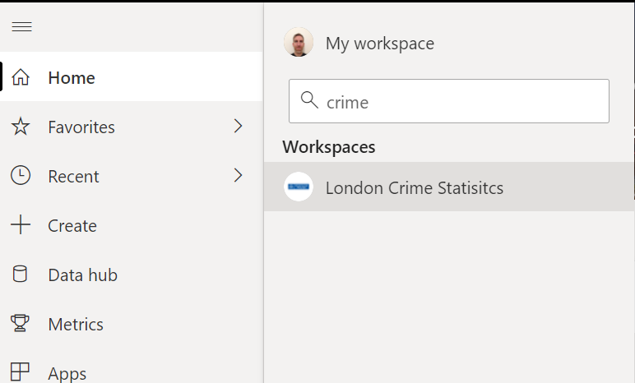

You are now ready to publish your report!

Publishing Your Report to Power BI Server

- In Power BI Desktop, choose File > Publish > Publish to Power BI or select Publish on the ribbon.
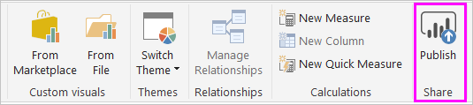
- Sign in to Power BI.
- Select the destination. (the workspace you created in the last section)
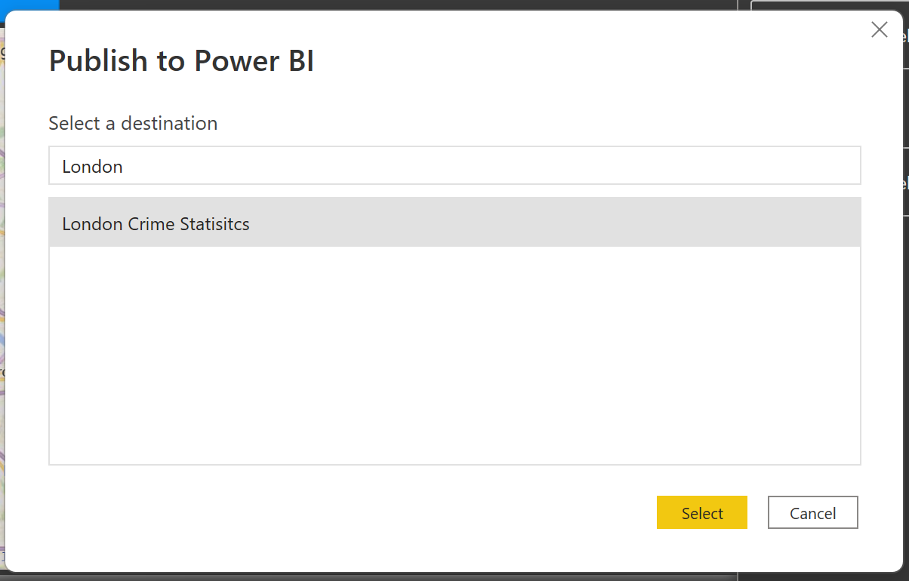
- When publishing is complete, you receive a link to your report. Select the link to open the report in your Power BI site.
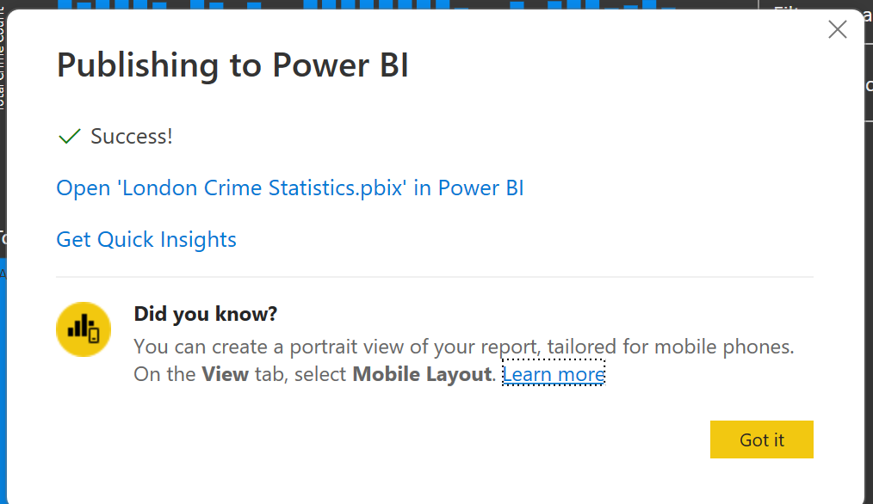

Add security groups to your semantic model (RLS)
In your workspace on the Power BI Service. Click on ‘security’ next to the semantic model (You will need to click on the ellipses to reach this).
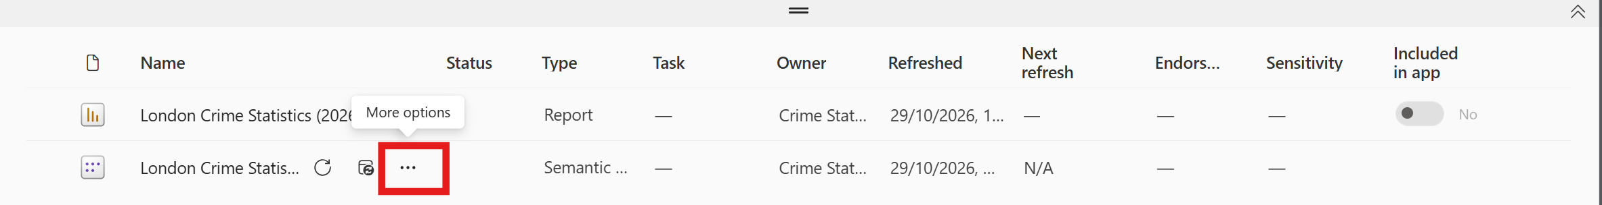
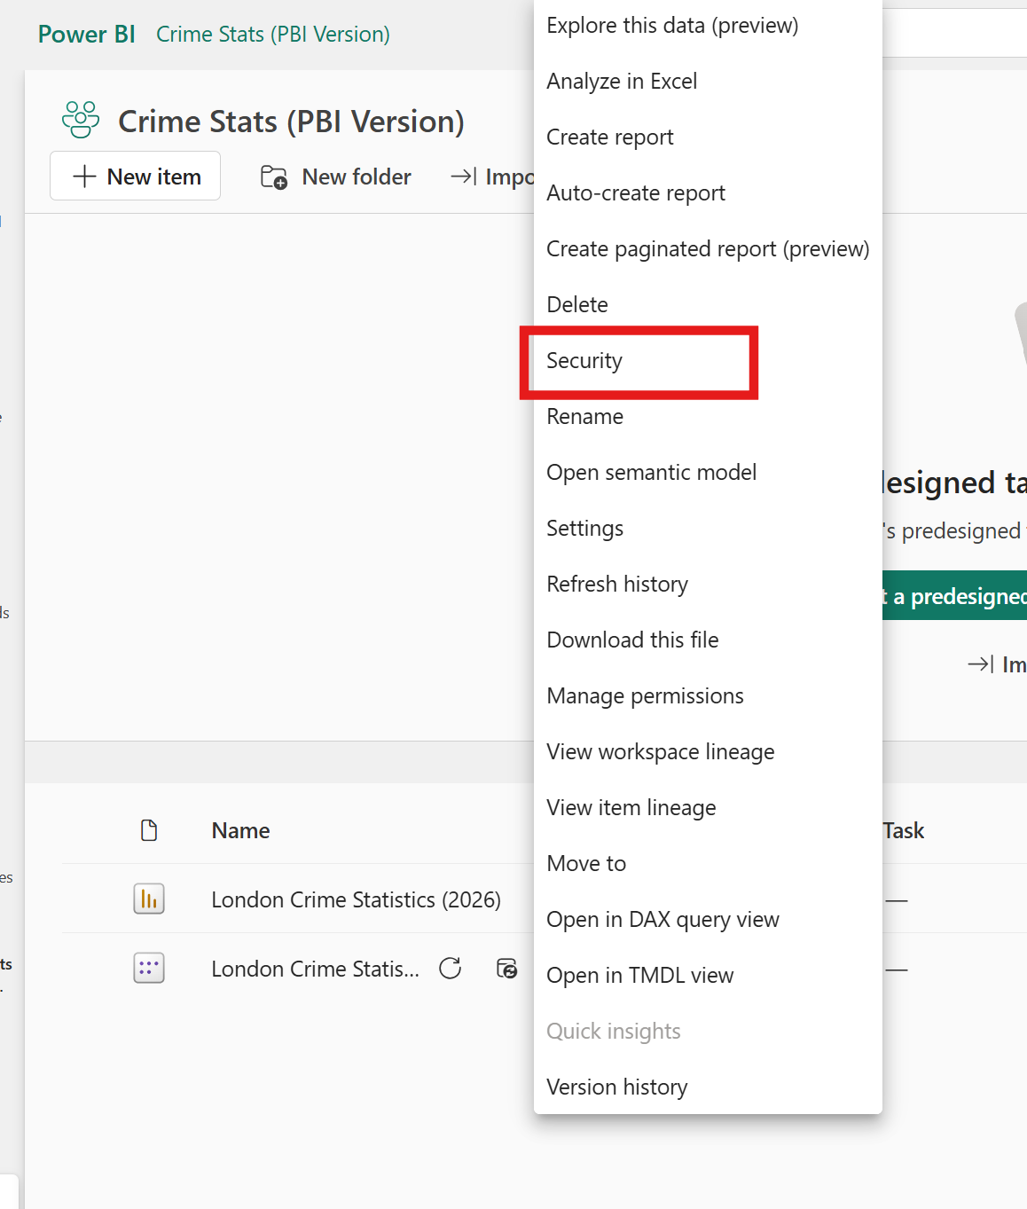
You will then see all the RLS groups you set up earlier. Simply add emails or security groups for each option to restrict what data people can see.
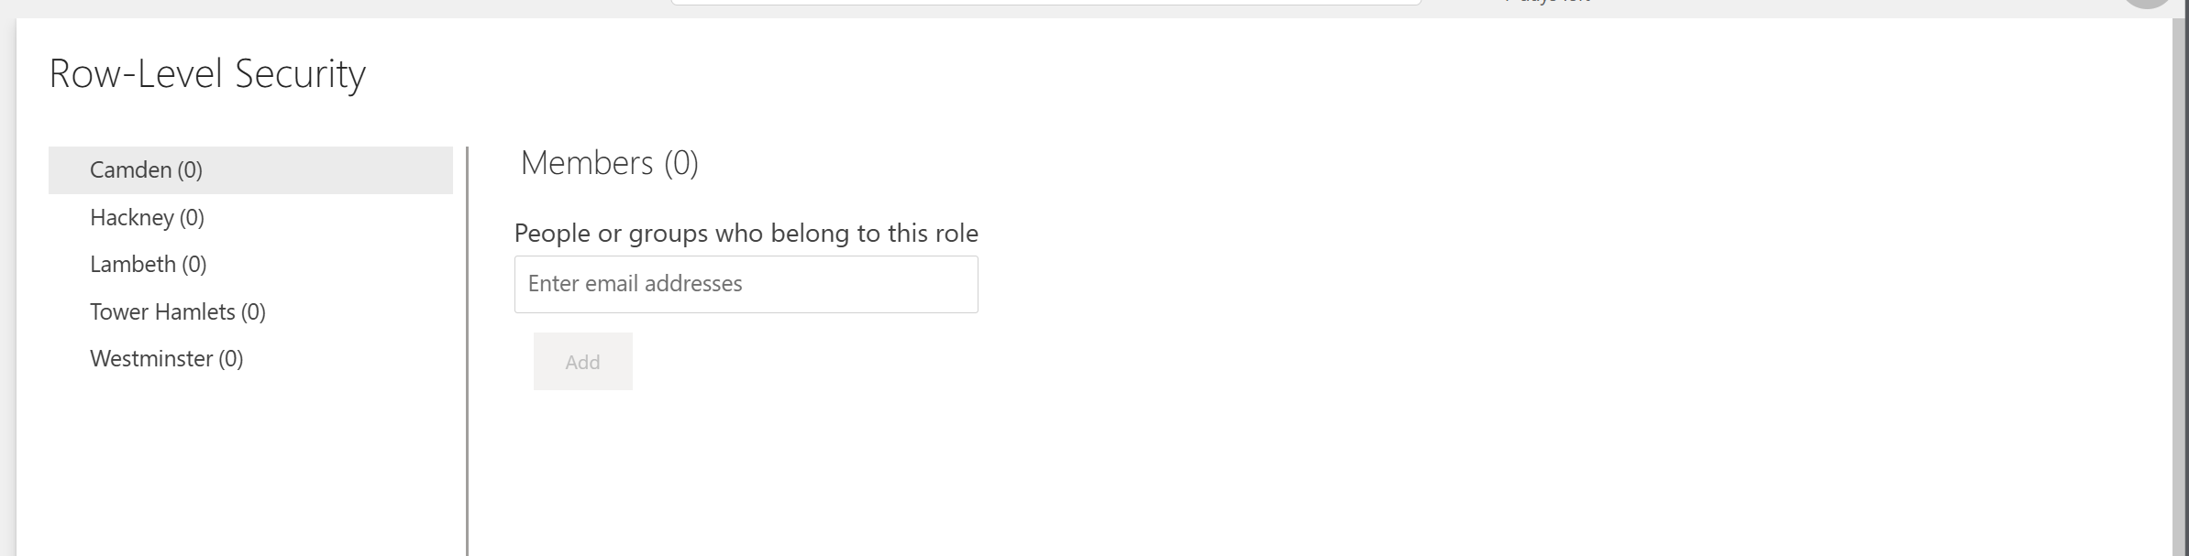

References
Power BI Documentation:
https://docs.microsoft.com/en-us/power-bi/
Power BI Community:
https://community.powerbi.com/
Data Analysis Expressions (DAX) Reference:
https://docs.microsoft.com/en-us/dax/
Charticulator:
https://charticulator.com/
Tips and Tricks:
https://docs.microsoft.com/en-us/power-bi/create-reports/desktop-tips-and-tricks-for-creating-reports
Power BI Blog:
https://powerbi.microsoft.com/en-us/blog/
Power BI Themes Gallery:
https://community.powerbi.com/t5/Themes-Gallery/bd-p/ThemesGallery
Create a Power BI Theme
https://themes.powerbi.tips/
Colour Formatting in Power BI
https://docs.microsoft.com/en-us/power-bi/visuals/service-tips-and-tricks-for-color-formatting

